Development of the Tau agrostudies portal for managing international agricultural internships

MEILTON C. LATOSA
ARVIN RUSSELL B. PRANDO

Republic of the Philippines
TARLAC AGRICULTURAL UNIVERSITY
Camiling, Tarlac
December 2025

APPROVAL SHEET

BIOGRAPHICAL SKETCH


Meilton C. Latosa was born in Camiling, Tarlac on March 10, 2000. He is the only child of Mr. Tobias R. Latosa Jr. and Mrs. Merlie C. Latosa.
He completed his elementary education at Camiling West Central Elementary School in March 2012, where he built a strong foundation in academics and developed his early interest in technology. He pursued his secondary education at Tarlac Agricultural University Senior High School. He graduated in March 2018, actively participating in various technology-related activities that further fueled his passion for computing—finishing his tertiary at Tarlac Agricultural University with a Bachelor of Science in Information Technology. With the knowledge and skills he has acquired throughout his academic journey, he aspires to contribute meaningfully to the Information Technology industry, particularly in software development, systems analysis, and innovative digital solutions.
<<SIGNATURE>>
MEILTON C. LATOSA

BIOGRAPHICAL SKETCH

Arvin Russell Prando was born on December 8, 2003 in San Carlos, Pangasinan. He is the youngest son of Mr. Arvin D. Prando and Mrs. Rhea B. Prando. He completed his primary education at Santa Ignacia North Central Elementary School in 2016 and his secondary education at Santa Ignacia Academy in 2022. He is currently a fourth-year student pursuing a Bachelor of Science in Information Technology at Tarlac Agricultural University. Through his academic training, he has developed knowledge and skills in information technology that enhance his analytical and problem-solving abilities. As he nears the completion of his degree, he aspires to join the Information Technology industry and contribute to technological development and innovation.

<<SIGNATURE>>
ARVIN RUSSELL B. PRANDO

ACKNOWLEDGMENT

Acknowledgment should briefly summarize individuals and funding institutions (if there is any) who provided assistance to the authors during the research study. It may also include English language critique, statistician, proof readers, etc. This shall include the member of the Advisory/Evaluation committee.

ABSTRACT

The Abstract should be a minimum of 150 words but not more than 300 words. Briefly state the objective of the research, the principal results and major conclusions.
Update the Table of Contents by clicking a space in the Table of Contents then Update Table without highlighting the texts. You may also right-click anywhere in the TOC, then choose Update Field then Update Entire Table.

TABLE OF CONTENTS

Development of the Tau agrostudies portal for managing international agricultural internships i
APPROVAL SHEET ii
BIOGRAPHICAL SKETCH iii
BIOGRAPHICAL SKETCH iv
ACKNOWLEDGMENT v
ABSTRACT vi
TABLE OF CONTENTS vii
LIST OF TABLES ix
LIST OF FIGURES x
LIST OF APPENDICES xi
INTRODUCTION 1
Background of the Study 1
Significance of the Study 3
Objectives of the Study 5
Scope and Delimitations 6
Definition of Terms 7
REVIEW OF RELATED LITERATURE AND STUDIES 10
METHODOLOGY 23
System Development Methodology 23
Data Gathering Procedures 25
System Design 26
Tools used in the Development 31
End User Evaluation 33
Unit Testing 37
Vulnerability Assessment and Penetration Testing (VAPT) 38
RESULTS AND DISCUSSION 40
Development of the TAU Agrostudies Portal for Managing International Agricultural Internships 40
User Requirements 41
Hardware and Software Requirements 51
End-User Evaluation Results 53
Unit Testing Result 64
SUMMARY, CONCLUSION AND RECOMMENDATION 68
Summary 68
Conclusion 70
Recommendation 73
REFERENCES 75
APPENDICES 76

LIST OF TABLES

Table 1. From "References" > Insert Caption > Table. Error! Bookmark not defined.
Table 2. Table Title Should end With a Period. 31
Table 3. Table Title Should end With a Period. 34
Table 4. Data Dictionary (if needed i.e. tabular dataset) Error! Bookmark not defined.
Table 5. Evaluation of Users on Software Usability. 54
Table 6. Accuracy of the IT Solution. 57

LIST OF FIGURES

Figure 1. From "References" > Insert caption > Figure 23
Figure 2. Screenshot Showing Evaluated Feature 64

LIST OF APPENDICES

Appendix A. User Interfaces 76
Appendix B. Sample Generated Reports 77
Appendix C. Evaluators' Questionnaire 78
Appendix D. Evaluators' Profile 79
Appendix E. Grammarian's Certificate 80
Appendix F. TAU-DRD-QF-43-Recommendation of Panel Members Form 81
Appendix G. TAU-CET-QF-01 Proposed Titles for Approval of Committee 82
Appendix H. TAU-DRD-QF-44-Thesis Title Approval Form 83
Appendix I. TAU-DRD-QF-45-Thesis Outline Approval Form 84
Appendix J. TAU-DRD-QF-34 Ethics Checklist 85
Appendix K. TAU-DRD-QF-47 Request for Oral Examination (Outline) 86
Appendix L. TAU-CET-QF-05 Evaluation Form for Outline Presentation 87
Appendix P. TAU-DRD-QF-35 Endorsement of Research Ethics 88
Appendix R. TAU-DRD-QF-47-Request for Oral Examination (Final Defense) 89
Appendix S. TAU-CET-QF-05-Evaluation Form for Outline/Oral Presentation (Final Defense) 90
Appendix T. TAU-CET-QF-10-Approval for Final Circulating Copy 91
Appendix U. TAU-DRD-QF-39-Test for Similarity Index 92
Appendix V. TAU-DRD-QF-40-Similarity Index Certificate 93

INTRODUCTION

Background of the Study
Agricultural internships play a vital role in providing students with practical exposure to farming, agribusiness, and modern agricultural technologies. Countries such as Israel have established comprehensive training programs for international students, integrating theoretical instruction with hands-on farm experience. Programs like Agrostudies in Israel have demonstrated significant positive outcomes in enhancing the competencies and technical skills of foreign agricultural students (Smith & Lee, 2021).
In the Philippine context, specialized agricultural training is particularly important. Institutions such as Tarlac Agricultural University (TAU) recognize the value of sending students abroad for experiential learning. However, the current system for processing applications, monitoring student deployment, and assigning farm placements remains largely manual and inefficient. Reliance on paper-based documents, email correspondence, and face-to-face coordination often results in delays, miscommunication, and a lack of real-time updates for both students and administrators (Gonzalez et al., 2020). Furthermore, students have limited participation in selecting their farm assignments, which may lead to unsuitable placements and unsatisfactory training experiences.
The digitalization of education has changed administrative tools face all over the world. Many universities have adopted online portals for students management and internship deployment for improving (Cheng & Yu, 2019). For example, the Erasmus+ Student Mobility Management Platform in Europe has helped streamline the process of setting up international student exchange programs by providing information-hub features including document submission, real-time application tracking and internship matching (Johansson & Eriksson, 2022). Such platforms have been particularly useful in the agricultural sector in Asia where students could browse through the farms available for their deployment, compare opportunities and select the ones that suit them (Wong & Tan, 2021).
Due to the growing demand for a more transparent system centered on graduate students, this study proposes the development of the TAU Agrostudies Portal. This capstone project will culminate in s web-based system that will streamline the application process, assist with farm selection, and provide real-time updates on student placements. The system will use data analytics to track applicant statistics, automate document verification, and increasingly connect students, coordinators, and farm partners located in Israel.
The TAU Agrostudies Portal aims to improve the student experience, lessen the burden of administrative work and streamline communication between stakeholders by leveraging technology to address the inefficiencies of the manual process. The late-night marketing of TAU leads to a more efficient use of the system, an automatic deployment into a farmer 'home' that better matches the skills and preferences of its students and provides a much better learning experience designed for international agricultural training.

Significance of the Study
This Capstone Project will help in achieving Sustainable Development Goal SDG 4: Quality Education, because it promotes equal access to quality internship opportunities, ensuring that students receive hands-on experience in international agricultural training programs. By digitizing the internship deployment process, the system contributes to improved educational outcomes and efficient skill development.
This Capstone Project will help in achieving Sustainable Development Goal SDG 8: Decent Work and Economic Growth, because it enhances the employability and career readiness of agricultural students through structured international training placements. The system facilitates transparent and merit-based farm assignments that align with students' skills and career aspirations, thereby preparing them for meaningful employment in the agriculture sector and contributing to economic productivity.
This Capstone Project will help in achieving Sustainable Development Goal SDG 9: Industry, Innovation, and Infrastructure, because it integrates digital innovation into the university's administrative operations, modernizing the management of international internship programs. The web-based portal leverages technology to create efficient, scalable infrastructure for educational services, demonstrating how institutions can adopt innovative solutions to improve operational processes.
This Capstone Project will help in achieving Sustainable Development Goal SDG 9: Industry, Innovation, and Infrastructure, because it integrates digital innovation into the university's administrative operations, modernizing the management of international internship programs. The web-based portal leverages technology to create efficient, scalable infrastructure for educational services, demonstrating how institutions can adopt innovative solutions to improve operational processes.
For Tarlac Agricultural University (TAU), this IT Solution will help in managing student applications more effectively, reducing paperwork and ensuring accurate tracking of student placements. It will also facilitate seamless communication between TAU administrators and international farm partners, improving overall coordination and efficiency.
For Student Placement Office (SPO), this will aid them in streamlining administrative workflows, minimizing delays in processing applications, and enhancing transparency in student selection and deployment. This system will also provide real-time analytics on student progress and farm availability, allowing data-driven decision-making for institutional improvements.
For students, this will benefit them when students can select their preferred farm placements, track their application status in real time and receive timely notifications regarding their deployment. The system ensures that students are placed in farms suited to their skills and preferences, leading to a more productive and satisfactory internship experience.

Objectives of the Study
For students, this will benefit them when students can select their preferred farm placements, track their application status in real time and receive timely notifications regarding their deployment. The system ensures that students are placed in farms suited to their skills and preferences, leading to a more productive and satisfactory internship experience.
Specifically, the study aims to achieve the following objectives:
- to develop a fully functional system with the following components:
a.1 an administrator interface for managing and tracking agricultural program candidates;
a.2 a document review and decision-making module for evaluating applicant eligibility;
a.3 a reporting and data export feature for generating and managing records;
a.4 a user management system with secure authentication and role-based access control.
- To evaluate the developed system based on the ISO/IEC 25010 standard in terms of:
b.1 Usability
b.2 Functionality
- To perform unit testing to ensure the reliability and correctness of system components.
- To conduct Vulnerability Assessment and Penetration Testing (VAPT) to:
d.1 identify potential security vulnerabilities;
d.2 assess the system’s resistance to common web attacks such as SQL injection, cross-site scripting (XSS), cross-site request forgery (CSRF), insecure direct object references, and brute-force attacks;
d.3 evaluate the effectiveness of data protection mechanisms, including encryption, session management, and authentication;
d.4 provide recommendations to improve system security using tools such as OWASP ZAP.

Scope and Delimitations
The scope of this study includes the development, implementation and evaluation of the TAU Agrostudies Portal, a web-based platform for managing the application and deployment process of students participating in international agricultural internships. The system covers candidate registration, document management, application tracking, status monitoring, administrator management, and report generation.
The system provides report generation in multiple formats (CSV, Excel, PDF, DOCX) but does not include advanced data analytic or predictive modeling. User roles are limited to administrators and regular users, with specific permissions based on these roles.
The evaluation of the system will be conducted through candidate users, TAU administrators, and university representatives, without involving external software usability experts beyond institutional stakeholders.
The project’s timeline is limited to one academic year, covering system development, implementation, and testing phases.

Definition of Terms
Application Status The status of a student’s applications in the system, namely whether it’s Pending, Approved or Rejected. This ensures that students who wish to apply for the Agrostudies program have a transparent selection process.
Authentication System A security mechanism that verifies the identity of users before granting access to the system. This includes OTP verification for candidates and temporary admin code validation for administrator creation.
Data Export A feature that allows administrators to generate and download reports in PDF or Excel format containing applicant details, application progress, and farm assignments.
Data Management TAU Agrostudies Portal collects and store information on students, including their student records and application details. Data Management includes the processes involved in the storage, retrieval, and organization of students records. It also ensures that every data is secure, accessible and up to date.
Document Upload System A facility for provision of required documents for processing — and submission of passports, academic records and medical certificates; providing all files for evaluation.
Farm Selection Module A system feature enabling approved candidates to choose an available farm placement in Israel instead of being automatically assigned.
Functionality The variety of tasks that a software program or component can carry out is referred to as software functionality. It is the actual application or practical usage of software in a real-world setting. The set of features or capabilities that the software provides to its users determines its functionality.
Role-Based Access Control (RBAC) A security feature that restricts system access based on user roles (Candidate, Admin, Super Admin). This ensures candidates cannot access admin functionalities and vice versa.
Sorting and Filtering As the name suggests, this feature helps admins filter through their applicants based on criteria like age, gender, application status (submitted/in progress) and document completeness. It increases efficiency in student application processing.
Student Portal The Student Portal is the online gateway for applicants to submit their application, upload necessary documents, check the status of their application and choose a farm after approval. In other words, it is the point that interacts with students the most.
Temporary Admin Code A one-time-use code generated by a Super Admin required for creating an Admin account to ensure controlled access and prevent unauthorized account creation.
Usability Software usability is the regulated aspect of user experience design that ensures consumers don't encounter issues when utilizing a product or user interface. It gauges how happy end customers are with what they can do with the interface.

REVIEW OF RELATED LITERATURE AND STUDIES

This chapter presents the related literature and studies that involve the development of the TAU agrostudies portal for managing international agricultural internships. In this chapter, the researchers aimed to highlight the gap between the present study and previously conducted research.
Web portals are centralized systems that help Higher Education Institutions (HEIs) manage their information. A thorough literature study by Pinho, Franco, and Mendes (2018) emphasized the various functions of web portals, such as information management, software use, internal and external advantages, and technology acceptability. Their research emphasizes how important online portals are for decision-making and how HEIs must have customized portals that meet their unique requirements. By integrating these portals, academic personnel may communicate more effectively and institutional information can be managed more effectively.
One of the primary topics of this research is the automation of internship management through the use of web-based solutions. According to the study of Gosal, Wasino, and Tony (2024) shown in their study at FTI UNTAR how automating internship data processes can significantly reduce administrative workload while enhancing monitoring and data accuracy. The implementation of standardized workflows, integrated dashboards, and real-time progress updates led to improved communication between students, academic coordinators, and industry partners. Similarly, Lyceum of the Philippines University in Cavite created a web-based internship administration system, as explained by Pocaan (2021). The system decreased data loss and fragmentation by centralizing student records, document submissions, and performance reviews. This study emphasized the importance of real-time feedback and easily accessible interfaces for geographically dispersed systems.
A web-based internship system with features catered to the need of educational stakeholders was developed in parallel by Abdullah et al. (2020). The application's timetable management, hour monitoring, and report generation features highlight the growing demand for digital solutions tailored to academic and business environments.
The necessity to expedite communication, data access, and monitoring procedures has led to an increasing trend in the digitalization of services associated to internships and academics. The difficulties colleges confront in manually overseeing internship programs, including monitoring student progress, protecting private information, and guaranteeing real-time cooperation among stakeholders, were discussed by Lumbog and Gaspar (2023). In response, their research developed an online Internship Management System (IMS) that streamlines these administrative duties. By implementing role-based access, the suggested system enabled coordinators, advisers, and students to carry out particular tasks—like uploading documents, updating statuses, and submitting feedback—without the need for human involvement. A model like this illustrates how centralized portals might improve academic programs' accountability and real-time communication (Lumbog & Gaspar, 2023).
Mobile-based monitoring is already a crucial part current internship supervision, particularly for programs that call for remote placements or fieldwork. Using progress-tracking algorithms, GPS-based activity logging, automated daily reporting, and digital time records greatly increased accountability and decreased manual errors as compared to traditional monitoring, according to a study on a mobile-based student internship monitoring system. The researchers stressed that mobile-first solutions are especially relevant to agricultural and off-site internship programs since they guarantee ongoing oversight even in remote places (R. Gupta & P. Ashok, 2020).
Additionally, web-based internship portals continue to be a popular way to increase administrative effectiveness. Centralizing student records, supervisor ratings, and on-site visit logs improved data accuracy and decreased administrative delays, according to a study on the Web-Based Application of the Internship Management System. Users gave the system good ratings for overall satisfaction, usefulness, and convenience of use, highlighting the benefits of switching from manual paperwork to an integrated digital platform (N. D. Guzman & R. A. Malik, 2021).
A recent study also developed an architectural web-based monitoring system utilizing PHP Laravel and Tailwind CSS, specifically intended to manage internship time logs, project progress, and compliance. According to the authors, the centralized dashboard increased transparency between students and supervisors, decreased human error, and minimized unauthorized record adjustments. These results support the efficacy of automated, organised online monitoring for academic internship programs (S. Prakash & D. Kumar, 2023).
Another important component of successful internship systems is user-centred design. Creating an internship information portal based on user experience research resulted in much superior usability scores, according to a study employing the Design Thinking method. The system received good pragmatic and hedonic quality scores using the UEQ-S instrument, demonstrating that responsive interfaces, easy navigation, and an intuitive layout directly increase student and coordinator satisfaction (S. Nurhasanah et al., 2022).
In Vocational Education and Training (VET) programs that include Work-Based Learning (WBL), effective stakeholder engagement is essential. In order to guarantee the success of WBL projects, based from the study of Ramli, Zakariah, and Ab Halim (2024) which emphasized the significance of cooperative efforts among students, industrial partners, and educational institutions. The study highlights several WBL methods and the difficulties in including stakeholders, arguing for shared accountability to produce high-quality training results. In order to match educational programs with industry demands and improve graduates' employability, a cooperative approach is crucial.
Haron et al. (2019) sought to determine the competencies that businesses consider critical for graduates of vocational colleges. Their results emphasized the importance of critical thinking, communication, and problem-solving abilities. Furthermore, in order to better prepare students for the workforce, vocational schools ought to incorporate these skills into their curricula. This kind of alignment guarantees that graduates have the skills needed to satisfy the ever-changing demands of the job market.
Vocational colleges' On-the-Job Training (OJT) programs encounter a number of obstacles that can hinder their efficacy. Othman et al. (2023) studied issues like training placement suitability, supervision quality, evaluation procedures, and financial allowances, and their study suggests creating a comprehensive database of local industries that offer OJT opportunities to guarantee suitable student placements. Resolving these issues is essential to improving the quality and relevance of OJT programs, which in turn improves student learning experiences and results.
The increasing importance of ICT in the fields of education and agribusiness is demonstrated by the digitization of internship management systems and agriculture. The factors impacting ICT adoption among Somalia's small-scale agribusinesses were investigated by Abdullahi et al. (2021). According to their research, perceived ease of use, government assistance, and technological preparedness all have a big impact on ICT adoption. These findings imply that infrastructure and support systems are necessary for the effective integration of digital platforms, like internship portals, in education pertaining to agriculture.
Mobile-based solutions have demonstrated significant potential for projects that need flexible supervision. Castro (2024) found that a mobile-based internship monitoring system that uses progress tracking algorithms to evaluate student performance over time was put into place. Access is guaranteed even in remote or rural agricultural locations thanks to the mobile-first architecture. providing a solid example in which interns might be assigned to remote settings.
Similarly, Salvador et al. (2024) investigated how a web-based database for research consortiums might facilitate data-driven decision-making and project coordination. Their findings, which are similar to the design of TAU's worldwide internship programs, demonstrate the value of organize, easily accessible data platforms in intricate, multi-institution collaborations, notwithstanding their concentration on research administration.
Additionally, there are new chances to enhance international agricultural internships through the use of data analytics and network mapping. In a thorough mapping study on data analysis in social networks for agribusiness, Soares et al. (2022) focused on how digital data ecosystems may be used to improve institutional strategy, market forecasts, and stakeholder communication. These methods can also be used on internship portals, which use social data to monitor placement patterns, student development, and institutional collaborations.
The usefulness of user interface design in web-based learning environments was studied by Castillejos et al. in 2022. Their study made clear how crucial it is to follow user-centered design guidelines in order to increase student satisfaction, decrease user error, and improve navigation. Since internship management systems serve a variety of stakeholders, such as students, coordinators, and industry partners, these guidelines are very important.
A real-time communication mechanism was established by Yusof and Hashim (2023) as part of an internship portal to enable continuous updates and interactions amongst stakeholders. Throughout the internship, their technology enabled virtual consultations, messaging, and warnings, which improved response and mentorship.
The effects of incorporating internship management tools into already-existing LMS platforms, such Moodle, were examined by Fernandez and Rivera (2021). According to their research, having centralized access to course materials and internship monitoring data enhanced academic oversight and student compliance, making it simpler to evaluate students' performance in a comprehensive manner.
Gupta, S., and Kumar, V. (2022) studied how ICT tools are used in vocational training settings and discovered that learner engagement and results significantly improved. Their research backs the use of digital platforms to facilitate skill development, which is consistent with internship programs' objectives to improve employability.
Similarly, J. H. Lee and H. Kim. (2023) studied about how cloud computing technologies save time and effort in educational administration, especially internships. Their study highlights how organizations running extensive internship programs can benefit from lower IT expenses, scalable infrastructure, and improved data accessibility.
Zhang, Y., and Nakamura, T. (2021) studied the use of block chain technology to validate internship records and academic credentials. The study shows how block chain can help stakeholders in academic-industry partnerships maintain confidence, transparency, and data integrity. A decentralized, impenetrable ledger for storing and exchanging internship records can be offered via block chain technology. This strategy promotes better responsibility in international internship programs by securing credential authenticity and expediting verification procedures for potential employers, educational institutions, and governmental organizations.
According to Pinho, Franco, and Mendes (2018) points out, web portals serve as centralized solutions that greatly improve information management in Higher Education Institutions (HEIs). In order to facilitate decision-making and maximize communication among academic staff, their study emphasizes how crucial it is to customize these portals to the particular requirements of institutions. The necessity for specialized digital internship platforms that can efficiently handle complicated and varied internship data and procedures is supported by the fundamental function of web portals.
Numerous studies emphasize how automated, web-based platforms are replacing more conventional internship procedures. Digital solutions can facilitate real-time monitoring, improve stakeholder engagement, and streamline administrative procedures, as demonstrated by the systems created by Pocaan (2021), Abdullah et al. (2020) and Gosal et al. (2024). These characteristics are especially helpful for overseeing geographically dispersed or worldwide internship programs, as those in agriculture.
Integration, security, and accessibility also became major themes. While Castro (2024) and Mokhtar et al. (2023) emphasized mobile and LMS-integrated technologies that provide flexible access and real-time feedback, Lumbog and Gaspar (2023) developed passwordless authentication for safe login. Fernandez and Rivera (2021) went on to show that incorporating internship management tools into already-existing Learning Management Systems (LMS) such as Moodle improves student compliance and academic oversight by offering centralized access to course materials and monitoring data. Students having restricted access to technology or participating in remote field placements may find these advancements particularly pertinent.
The importance of industry relevance and stakeholder participation is another major area of study attention. Haron et al. (2019) and Ramli et al. (2024) emphasized the significance of ongoing cooperation between academic institutions and business partners to guarantee that internship programs stay in line with changing labor market demands and real-world expectations.
The effectiveness of On-the-Job Training (OJT) programs in vocational colleges is impacted by a number of issues. Othman et al. (2023) studied into aspects including financial allowances, supervision quality, evaluation processes, and training placement suitability. To guarantee suitable placements and raise the standard of the program as a whole, they suggested creating an extensive database of nearby firms that provide OJT possibilities. Improving student learning outcomes and experiences requires addressing these issues.
In terms of ICT adoption and digital infrastructure, Salvador et al. (2024), Kumar & Gupta (2022), and Abdullahi et al. (2021) explained the elements that affect the effective use of technology in agricultural and vocational contexts, including system accessibility, user training, and institutional preparedness. Their results highlight the need for user-friendly, scalable platforms.
Additionally, new technologies like blockchain and cloud computing promise to improve internship systems. Nakamura and Zhang (2021) emphasized the application of blockchain for safe, transparent, and impenetrable credential and internship verification, while Lee and Kim (2023) illustrated the cost-effectiveness and scalability of cloud-based platforms.
Similarly highlighted was the incorporation of data-driven decision-making and user-centered design approaches. Soares et al. (2022) talked about how data analytics may be used to assess program effectiveness and direct institutional strategies, whereas Castillejos et al. (2022) promoted responsive and user-friendly interfaces to increase user engagement.
Kaur, R., & Kaur, S. (2021) developed a web-based student placement management system designed to automate internship matching, document handling, and application tracking in higher education institutions. Their system improved transparency in placement decisions and reduced administrative delays through centralized digital workflows. The study highlights how structured online platforms enhance coordination between students, administrators, and partner institutions, which directly supports the need for a centralized international internship portal.
Alamri, A., & Alharbi, M. (2022) examined digital transformation in university administrative services and found that online portals significantly improve service delivery efficiency, data accuracy, and user satisfaction. Their research emphasized the importance of role-based access control, real-time updates, and secure authentication mechanisms in academic systems, supporting the architectural design of web-based internship portals.
Mendoza, J. P., & Santos, R. L. (2020) conducted a study on cloud-based student information systems and concluded that centralized platforms improve scalability, accessibility, and data reliability across multiple departments. Their findings support the use of cloud-ready architectures for systems managing large-scale academic processes such as international internships and student deployment programs.
Rahman, A., & Hossain, M. (2021) proposed a secure academic portal framework integrating encryption, authentication protocols, and access control mechanisms. Their research demonstrated that web-based academic systems with built-in security layers significantly reduce risks related to data breaches, unauthorized access, and identity theft, reinforcing the importance of security design in internship management systems.
Villanueva, C. J., & Dela Cruz, M. P. (2022) studied digital platforms for student mobility programs in Southeast Asia and found that centralized online systems improved application processing time, student satisfaction, and partner institution coordination. Their research supports the development of platforms that manage international student deployment and internship placement.
Ofori, K., Boateng, R., & Effah, J. (2020) analyzed e-government and e-education portal systems and concluded that integrated platforms improve institutional efficiency, transparency, and accountability. Their framework demonstrates how digital portals can support complex multi-stakeholder processes such as international training and exchange programs.
Singh, P., & Sharma, R. (2023) designed a role-based academic management system for universities that automated workflows for admissions, internships, and student services. The study showed that role-based access control improves data security and operational clarity, ensuring that users only access functions relevant to their roles.
Chowdhury, M. S., & Huda, M. (2021) explored ICT-based internship monitoring systems and found that digital tracking platforms significantly improve reporting accuracy, supervision efficiency, and student accountability. Their study supports the integration of monitoring and reporting tools in online internship systems.
Lim, K. H., & Teo, T. S. H. (2022) investigated user acceptance of university web portals and found that usability, perceived usefulness, and system reliability are critical factors in successful adoption. Their findings reinforce the importance of user-centered design in developing student internship portals.
Patel, N., & Desai, R. (2023) proposed a secure document management system for academic institutions that integrates automated verification, access control, and digital archiving. Their study showed that digital document systems reduce processing time and improve data integrity in administrative workflows, supporting document automation in internship portals.
Okoye, K., & Obi, T. (2021) examined digital transformation in higher education administration and concluded that integrated academic portals enhance institutional coordination and data-driven decision-making. Their research supports the use of analytics and reporting tools in student deployment systems.
Garcia, M. L., & Reyes, P. T. (2024) developed a web-based international student mobility platform that enabled real-time tracking, automated approval workflows, and partner institution coordination. Their findings showed improved operational efficiency and reduced processing delays, making their work directly relevant to international internship management systems.
These results provide compelling evidence for the creation of the TAU Agrostudies Portal as an all-inclusive online platform for managing internships. The portal should incorporate dashboards for performance evaluations, real-time communication tools, secure, mobile-responsive technologies, and flexible interfaces designed to meet the particular requirements of international agricultural internships. When taken as a whole, the evaluated studies offer a strong basis for developing a gateway that improves operational effectiveness, fosters skill development, and fortifies international institutional relationships. The additional literature on digital transformation, cloud architectures, security frameworks, and user acceptance further strengthens the case for a robust, scalable system that addresses inefficiencies in manual processes while prioritizing stakeholder coordination and data integrity.

METHODOLOGY

System Development Methodology
The researchers adopted the Agile Development Methodology in developing the TAU Agrostudies Portal due to its iterative and flexible approach. Agile allows continuous feedback, enabling the researchers to refine and improve the system throughout the development process.
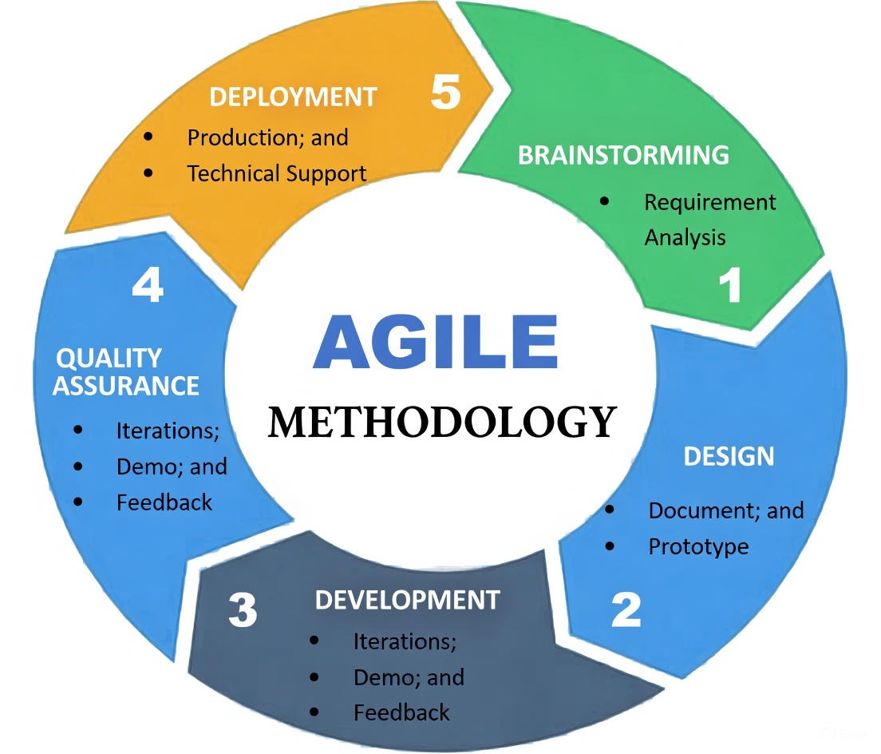
Figure 1. Agile Development Methodology
Brainstorming. The project team developed the system concept in response to input from a faculty member who recognized the necessity of an application and deployment management system for Agrostudies interns. This stage entailed determining the objectives of the system and creating a list of necessary functionalities, including document management, report generating, and candidate tracking.
Design. The group created the general system architecture and the user interface layout. To illustrate the platform's structure, wire frames and diagrams were made with programs like Lucid chart and Figma. Easy navigation for administrators and students, along with safe and effective document handling tools, were important design tenets.
Development. Technologies including HTML, CSS, JavaScript, and Django (Python) were used to convert the approved designs into a functional system. Essential features were put into place, including candidate filtering, document uploads, user registration, and authentication. Following each milestone, iterative development enabled testing and feature improvement, guaranteeing that functionality matched consumers' real needs.
Quality Assurance. To verify features, address errors, and improve performance, testing was done. Improvements were made based on input from advisers and early users, emphasizing usability, security, and dependability.
Deployment. The system was finally made available to end customers. Technical assistance was provided to address problems during this phase, and real-time testing with real users yielded useful insights. Agile is a continuous cycle, therefore the TAU Agrostudies Portal is always changing to meet the demands of its users. Feedback after deployment informs the subsequent iteration of enhancements.
Figure should be centered. The List of Figures must be automatically generated.

Data Gathering Procedures
To ensure that the TAU Agrostudies Portal effectively meets the needs of its users, various data gathering techniques were employed. These methods were used to identify system requirements, collect user feedback, and understand the operational workflow of the agrostudies application process at Tarlac Agricultural University (TAU). The study utilized both interactive and unobtrusive data gathering techniques to obtain comprehensive information.
Interview. An initial interview was conducted with a faculty member from a different department, who had previously expressed the need for a student placement and document management system. This discussion provided insight into the essential system functionalities required for the portal, such as document upload, approval or rejection of applications, and applicant sorting based on age, gender, and status. Additionally, the faculty member emphasized the importance of generating reports that summarize student demographics and application results. Another follow-up interview was conducted with the research adviser to validate the system’s feasibility and to ensure that it aligned with the university’s policies on student deployment programs. The feedback from these interviews guided the system design and feature development.
Questionnaire. A questionnaire was developed and distributed to potential users, including TAU agrostudies graduates and faculty members, to gather feedback on usability, efficiency, and expected features. The questionnaire covered areas such as ease of document submission (for students), convenience of document verification and approval (for admin users), effectiveness of the sorting and reporting system.
Suggestions for improving the system, responses from the questionnaire were analyzed quantitatively and qualitatively to refine the user interface (UI) and user experience (UX) design of the portal.
Document Sampling. To conceptualize the data requirements of the system, sample application documents were examined. This helped determine the necessary fields for document uploads, such as passports, diplomas, medical records, and recommendation letters. Additionally, existing records were reviewed to provide insight into how student application data was stored and processed, which assisted in designing the database structure of the system.

System Design
This section describes the system requirements from the developer’s perspective. It details the system architecture, entity relationship design, algorithms, tools, and technologies used in the development of the TAU Agrostudies System Portal.

Figure 2. Architectural design for TAU Agrostudies Portal

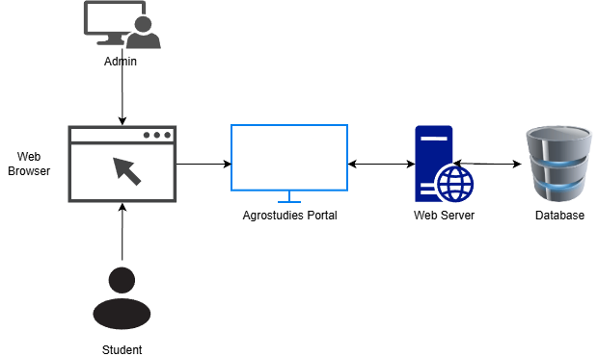
The TAU Agrostudies System Portal follows a Model-View-Template (MVT) architecture using the Django framework. It consists of three main layers:
Model Layer (Database & ORM). Defines the structure of the system’s database, including tables such as Auth User, Applicant, Farm, Farm Application, Document, and Notification. Utilizes Django’s Object-Relational Mapping (ORM) for database interactions.
View Layer (Business Logic & Processing). Handles user requests, processes form data, and applies validation. Includes views for registration, application submission, farm selection, document uploads, and admin approvals.
Template Layer (User Interface & Presentation). Uses HTML, CSS (Tailwind CSS), and JavaScript to render the front-end dynamically. Implements Bootstrap Icons and responsive UI design for usability across different devices.

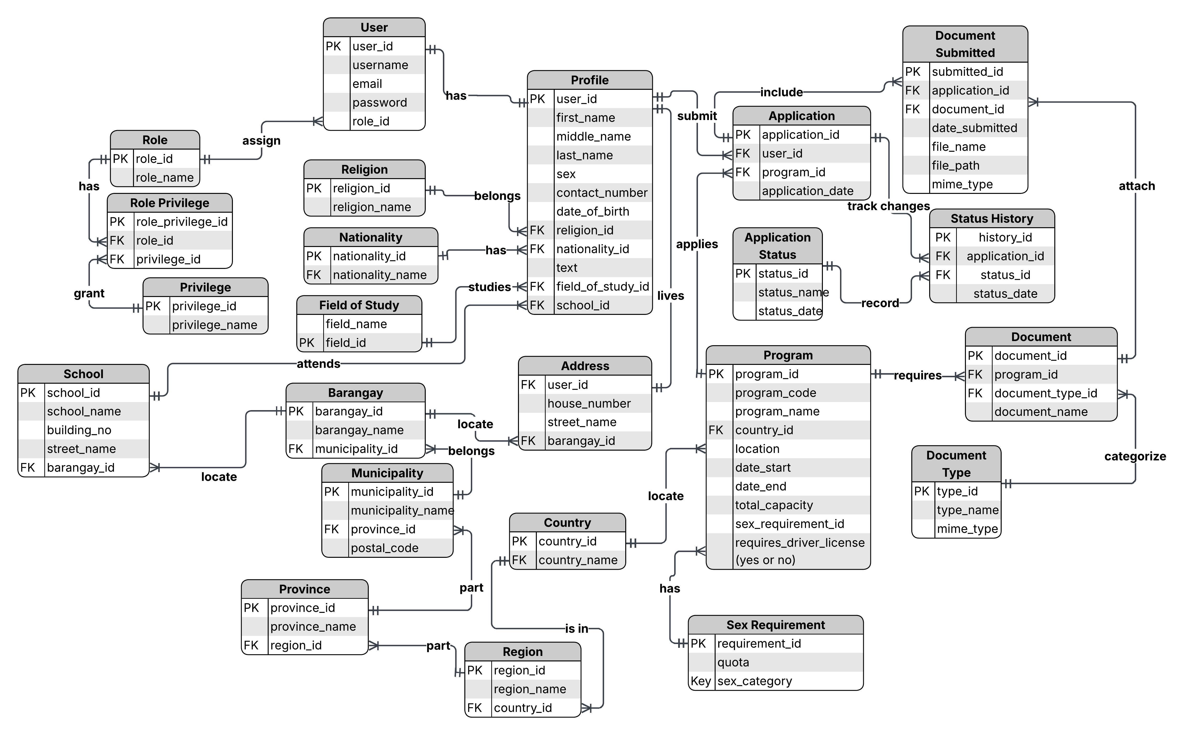
Figure 3. ERD for TAU Agrostudies Portal
Figure 3 provides a visual representation of the database structure, clarifying how different pieces of information are organized and related within the system.
Authenticated User. Entity is at the center, houses crucial user authentication information, such as login credentials and designated roles like administrator or applicant.
Applicant Entity. Each candidate's complete name, gender, student number, and links to their professional or social media profiles.
Farm. It is another important entity that includes detailed information about participating farms, including names, locations, agricultural specialties, and contact details.
Farm Application. Records student applications and acts as a liaison between applicants and farms. It contains sections for the motivation letter of the applicant, the application's current status (approved or pending), and timestamped submission records.
Document. Handles the upload and storage of necessary files in connection with this, keeping track of each document's metadata and verification information for each application.
Notification. Automated system-generated alerts for users, including administrator messages, document approval notices, and application status update.
Data. The TAU Agrostudies Portal collects and handles personal information from users to support the management of internship applications, farm placements, and report generation. This information includes students’ full names, gender, student numbers, contact details, links to professional or social media profiles, and uploaded documents such as passports, medical records, academic transcripts, recommendation letters, and motivation letters.
Furthermore, all sensitive data is 35 protected using strong encryption (AES 256), while login credentials like passwords are securely hashed using bcrypt. All data shared between users and the system is transmitted over a secure HTTPS connection. Access to the system is controlled through Role-Based Access Control (RBAC), ensuring that only authorized users (like admins or students) can view or manage specific information. The system also keeps an activity log to track who accessed or modified data. Only essential, non-sensitive details—such as the applicant’s name, application status, and farm placement—appear in system-generated reports. More sensitive or private data, like health records, social media links, and passwords, are never displayed or shared.
The researchers also state that the data collected from the system may be used or published in future studies, especially those related to agriculture, internship programs, or system development. Personal information will be removed before sharing to protect user privacy. This will be done following ethical guidelines and data privacy laws to ensure that all data is handled properly and securely.
Safety and Risk Assessment. The researchers made sure the TAU Agrostudies Portal is safe and reliable for users. They considered possible problems like system errors, human mistakes, and online threats such as spam, viruses, and hackers. To avoid these issues, the system is hosted on a trusted server with regular backups and monitoring. To prevent errors, the system was tested properly. It also has features like confirmation messages and activity logs to reduce mistakes made by users. To keep 36 the system safe from online attacks, it uses security tools like firewalls, encrypted passwords, and CAPTCHA to block spam. Only authorized users can access certain parts of the system. All information shared is protected with a secure connection (HTTPS). The system is also updated regularly to fix any new security issues. These steps help protect both the system and the users' personal information.

Tools used in the Development
Hardware. The development and testing of the system were conducted using following hardware
Table 1. Hardware
Component | Specification
Processor | AMD Ryzen 5 4500U
RAM | 8GB DDR4
Storage | 512GB SSD
Display | 14-inch Full HD
Operating System | Windows 11
Internet Connection | Required for deployment & email verification

Software. The software used by the researchers to develop the system includes the following.
- Backend Framework. At the core of the system’s backend is the Django framework, a high-level web framework written in Python. Django was selected for its built-in features such as user authentication, database management, and security, which significantly accelerate development while promoting clean and maintainable code.
- Frontend Technologies. The system utilizes HTML, CSS (with Tailwind CSS), JavaScript, and Bootstrap. HTML structures the content of the web pages, while CSS handles the visual styling. Tailwind CSS, a utility-first CSS framework, provides rapid design capabilities and ensures responsive, modern user interfaces. JavaScript adds interactivity to the system, enabling dynamic elements like drop downs and real-time validations. Bootstrap is used alongside Tailwind for its prebuilt components, improving consistency and speeding up UI development.
- Database. SQLite3 was used during system development due to its lightweight nature and minimal configuration requirements, making it suitable for prototyping and testing. For production deployment, PostgreSQL, a robust, scalable, and secure open-source relational database system, was used to manage higher data volumes and support multiple concurrent users.
- Version Control. Git is employed for version control, allowing the development team to track changes, manage different versions of the system, and collaborate effectively. The code base is hosted on GitHub, which provides cloud-based storage, collaboration features, and integration with CI/CD tools.
- Development Environment. Carried out using Visual Studio Code (VS Code), a lightweight but powerful source code editor with rich support for extensions, debugging, and version control. It streamlines the development workflow and enhances productivity with features like syntax highlighting, IntelliSense, and integrated terminal access.
- Testing Tools. The system leverages Django’s built-in test framework, which allows developers to write unit tests, simulate user behavior, and ensure that all features function as intended.

End User Evaluation
Scale to be Used in the Evaluation. The evaluation of the TAU Agrostudies Portal will employ a 5-point Likert scale to measure user satisfaction and expert assessment across various quality dimensions. This standardized measurement approach allows for quantitative analysis of qualitative feedback, providing a clear framework for interpreting the system's effectiveness.
Likert Scale. It measures participants’ level of agreement with statements related to the system usability and functionality.

Table 2. Table Title Should end With a Period.
first | level heading
4.50 – 5.00 | Excellent
3.50 – 4.49 | Very Satisfactory
2.50 – 3.49 | Satisfactory
1.50 – 2.49 | Satisfactory
0.00 – 1.49 | Poor

The weighted mean will be calculated for each evaluation criterion using the formula:
T Weighted Mean = Σ (Weight × Frequency) / Total Frequency (1)
where:
- Weight represents the Likert scale value (1-5)
- Frequency is the number of respondents selecting that weight
- Total Frequency is the total number of respondents
Table 3. Weighted Mean Scores
Weighted mean average | Description
4.21 – 5.00 | Excellent
3.41 – 4.20 | Very Good
2.61 – 3.40 | Good
1.81 – 2.60 | Fair
1.00 – 1.80 | Poor

Respondents to the Evaluation
The evaluation of the TAU Agrostudies Portal will be conducted at Tarlac Agricultural University (TAU), located in Camiling, Tarlac, Philippines. TAU is a premier agricultural institution that facilitates international agricultural internships for its students making it an ideal setting for implementing and evaluating the developed system. The university maintains partnerships with various international agricultural programs, particularly focusing on sending qualified candidates to agricultural training programs abroad.
The evaluation will involve two distinct groups of respondents to ensure comprehensive assessment from different perspectives:
The End Users consists Administrators staff members from TAU's International Affairs Office who are responsible for managing candidate applications, reviewing documents, and facilitating the deployment process. Regular Users are students and faculty members who use the system to register for programs, submit applications, or track candidate progress.
Faculty members from TAU’s Information Technology Department with expertise in web application development, database management, and system security were involved in reviewing and evaluating the technical aspects of the system. Agricultural Internship Coordinators, who have extensive experience in managing international agricultural internship programs, contributed their expertise in identifying and validating the specific requirements of the application process.
The study will employ stratified random sampling to ensure proportional representation from each stakeholder group. This technique involves dividing the population into distinct subgroups (strata) and then selecting participants randomly from each stratum.
The stratification will be based on user role (administrator vs. regular user);
Department affiliation. Experience level with similar systems.
The sample size will be calculated using Slovin's formula to ensure statistical validity:

n = 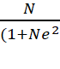 (2)
where:
- n = sample size
- N = total population
- e = margin of error (0.05 for 95% confidence level)
For each stratum, the specific sample size will be determined using proportional allocation:
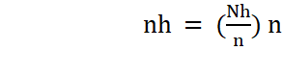 (3)
where:
- n_h = sample size for stratum h
- n = total sample size
- N_h = population size for stratum h
- N = total population
Based on the current TAU population involved with the agricultural internship program:
End Users will be
- Administrators (N = 15): With e = 0.05, n = 14;
- Regular Users (N = 200): With e = 0.05, n = 134.

Unit Testing
The researchers conducted unit testing to ensure that each module of the TAU Agrostudies Portal functions correctly and meets the specified requirements prior to system integration and user evaluation. Unit testing focused on verifying the accuracy, reliability, and performance of individual components of the system.
Each module was tested independently, including user authentication, applicant profile management, application submission and tracking, document upload and verification, administrative dashboard operations, and report generation. Predefined test cases were developed for every module to validate input and output correctness, data validation rules, system responses, and error handling mechanisms.
During testing, the researchers simulated various user actions and scenarios to ensure that all functionalities operated as intended. Any identified errors, bugs, or inconsistencies were immediately corrected and retested to confirm resolution.
The results of the unit testing confirmed that all core system components were functioning properly, stable, and ready for integration and deployment. This process ensured that the system delivered accurate outputs and provided a reliable user experience.

Vulnerability Assessment and Penetration Testing (VAPT)
The researchers carried out a comprehensive Vulnerability Assessment and Penetration Testing (VAPT) to ensure the security and integrity of the TAU Agrostudies Portal. This procedure aimed to identify potential security vulnerabilities and evaluate the system’s resilience against common web-based attacks.
The assessment was conducted using the OWASP Zed Attack Proxy (OWASP ZAP), a widely used web application security testing tool. The system was tested against various threats such as SQL injection, cross-site scripting (XSS), cross-site request forgery (CSRF), insecure direct object references, and brute-force login attempts.
Furthermore, the study evaluated the effectiveness of the system’s security mechanisms, including data encryption, session management, authentication controls, and role-based access control. Simulated attack scenarios were performed to assess how the system responded to potential threats and unauthorized access attempts.
All identified vulnerabilities were documented, analyzed, and addressed by implementing appropriate security measures. Necessary improvements were applied, including strengthening input validation, enhancing authentication mechanisms, and securing data transmission through HTTPS protocols.
The results of the VAPT demonstrated that the system was secure, resilient against common cyberattacks, and capable of protecting sensitive user information. This confirmed that the TAU Agrostudies Portal provided a safe and reliable platform for both students and administrators.

RESULTS AND DISCUSSION

Development of the TAU Agrostudies Portal for Managing International Agricultural Internships
The development of the TAU Agrostudies Portal for Managing International Agricultural Internships focuses on designing and implementing a centralized web-based system that addresses the limitations of the existing manual processes in handling internship applications and deployment at Tarlac Agricultural University. The system was developed to streamline and automate key processes such as student registration, document submission and verification, internship program management, farm selection, and application tracking. By integrating these functionalities into a single platform, the system aims to improve efficiency, accuracy, and accessibility in managing international agricultural internship programs.
The development process involved careful planning of system requirements, database design, interface development, and implementation of security mechanisms to ensure data integrity and controlled access. The system was built using the Django framework following a structured Model-View-Template architecture to promote maintainability and scalability. In addition, the design emphasizes usability and responsiveness to ensure that both students and administrators can efficiently interact with the platform across different devices.

User Requirements
The user requirements for the TAU Agrostudies Portal were established to define the fundamental functionalities required by administrators and student applicants in managing international agricultural internship processes. By categorizing these requirements according to user roles, the system is ensured to adequately support the specific responsibilities and functions of each user group.
For student applicants, the system provides functionalities that support the internship application process, including user registration and authentication, profile management, document submission, application tracking, and farm selection upon approval. These features ensure that candidates can efficiently complete and monitor their internship applications within a centralized platform, thereby minimizing the need for manual processing and fragmented communication.
For administrators, the system includes requirements that support the management and evaluation of applications, such as reviewing and approving candidates, verifying submitted documents, managing internship program details, and generating reports. These functionalities enable administrators to systematically handle internship placements, assess applicant qualifications, and monitor application data in an organized and efficient manner.
This part should explain what the system will do from the user’s perspective or view. It should discuss the features per module of the system.
This section presents the logical design of the IT Solution as a result of the requirement specification phase or activity. It presents the data intake of system, how it is processed or transformed and what is the output.
The logical design can either be either of the following. This can also be the conceptual framework of the IT Solution or the study.
Input Process Output (presented per permission or perspective of user – User, Administrator, etc)
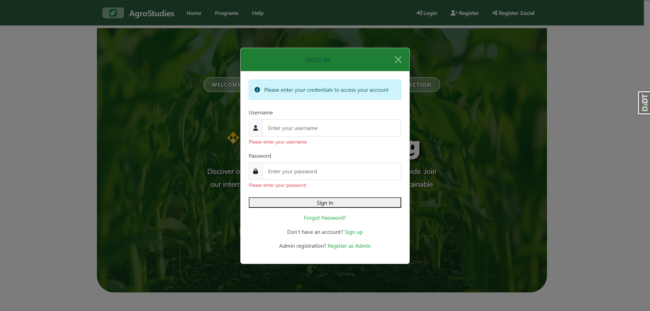
Figure 3. User Login and Authentication Interface

Figure 3 presents the user login and authentication interface of the TAU Agrostudies Portal. This module serves as the primary access point to the system, requiring users to input their registered credentials for verification. It incorporates input validation and secure authentication mechanisms to prevent unauthorized access and ensure data integrity. Furthermore, the interface supports role-based access control, allowing the system to differentiate permissions between administrators and regular users. This functionality is essential in maintaining system security and ensuring that only authorized individuals can access specific features and sensitive information.
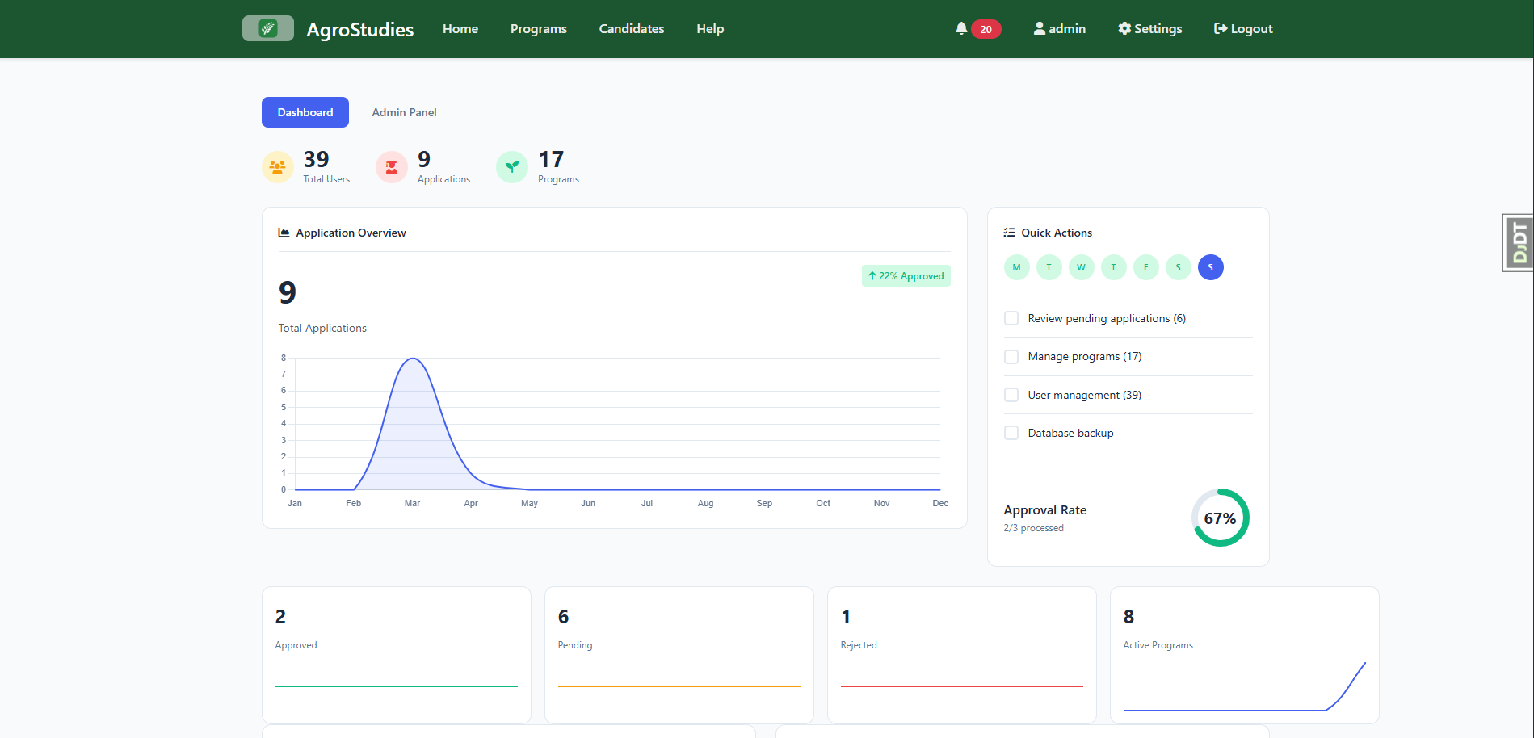
Figure 4. Administrator Dashboard Overview

Figure 4 illustrates the administrator dashboard, which functions as the central control panel of the system. It provides a comprehensive overview of key operational data, including the total number of applicants, application status distributions, and system notifications. The dashboard is designed to facilitate efficient monitoring and decision-making by presenting summarized information in an organized and accessible manner. Additionally, it offers quick navigation to core modules such as candidate management, program management, and report generation, thereby enhancing administrative productivity and workflow efficiency.
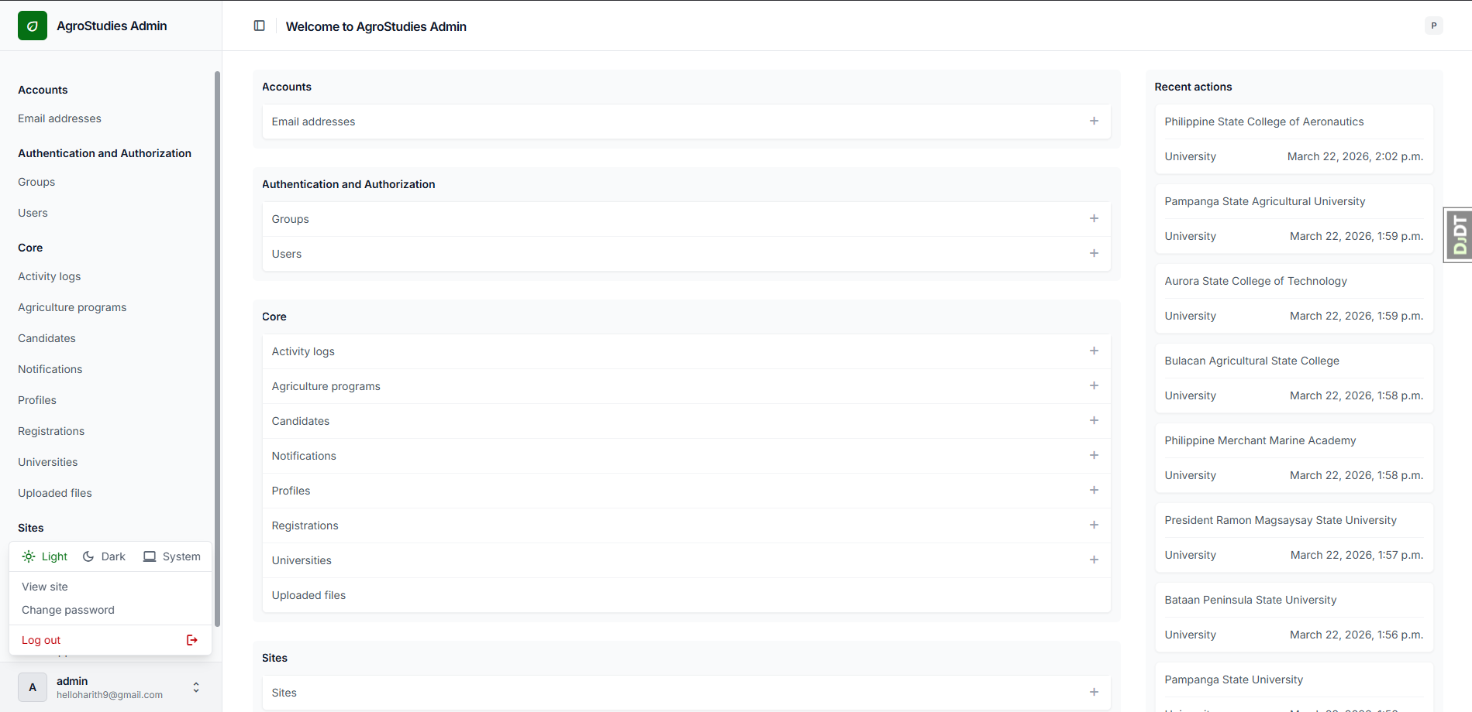
Figure 5. Administrator Settings Interface

Figure 5 shows the administrator settings interface, where system configurations and account-related preferences can be managed. This module enables administrators to update personal account information, modify system settings, and configure security-related parameters. It plays a crucial role in maintaining administrative control over system operations and ensuring that system behavior aligns with institutional requirements. By providing centralized access to configurable options, the interface supports flexibility, system customization, and improved management of platform settings.

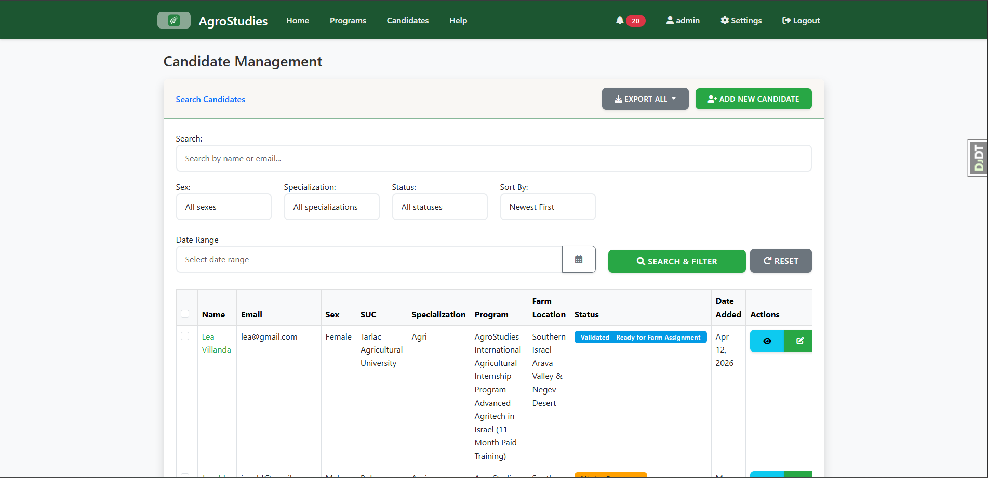
Figure 6. Candidate Management Module Interface

Figure 6 presents the candidate management module, which allows administrators to efficiently manage and evaluate applicant records. The interface provides functionalities such as filtering, sorting, and searching based on specific criteria including application status, gender, and document completion. This structured approach enhances the efficiency of the selection process by enabling administrators to quickly identify qualified candidates. Moreover, the module supports informed decision-making by presenting organized and accessible applicant data, thereby improving the overall management of the internship application process.

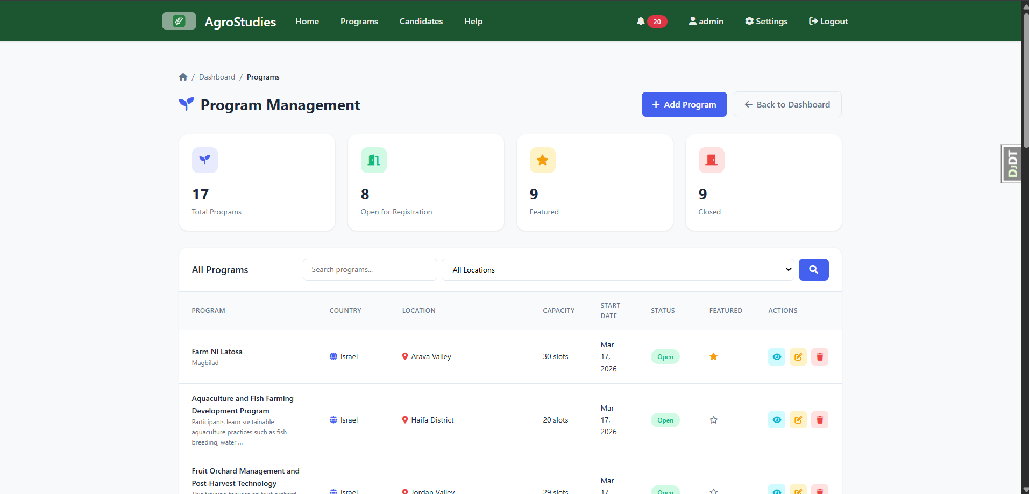
Figure 7. Internship Program Management Interface

Figure 7 illustrates the internship program management interface, which is used to organize and maintain information related to available internship opportunities. Through this module, administrators can manage farm details, program descriptions, and availability of slots for deployment. The interface ensures that internship listings remain accurate, updated, and accessible to users. This functionality is critical in maintaining the integrity of program data and ensuring that students are provided with relevant and reliable information when selecting their preferred internship placements.

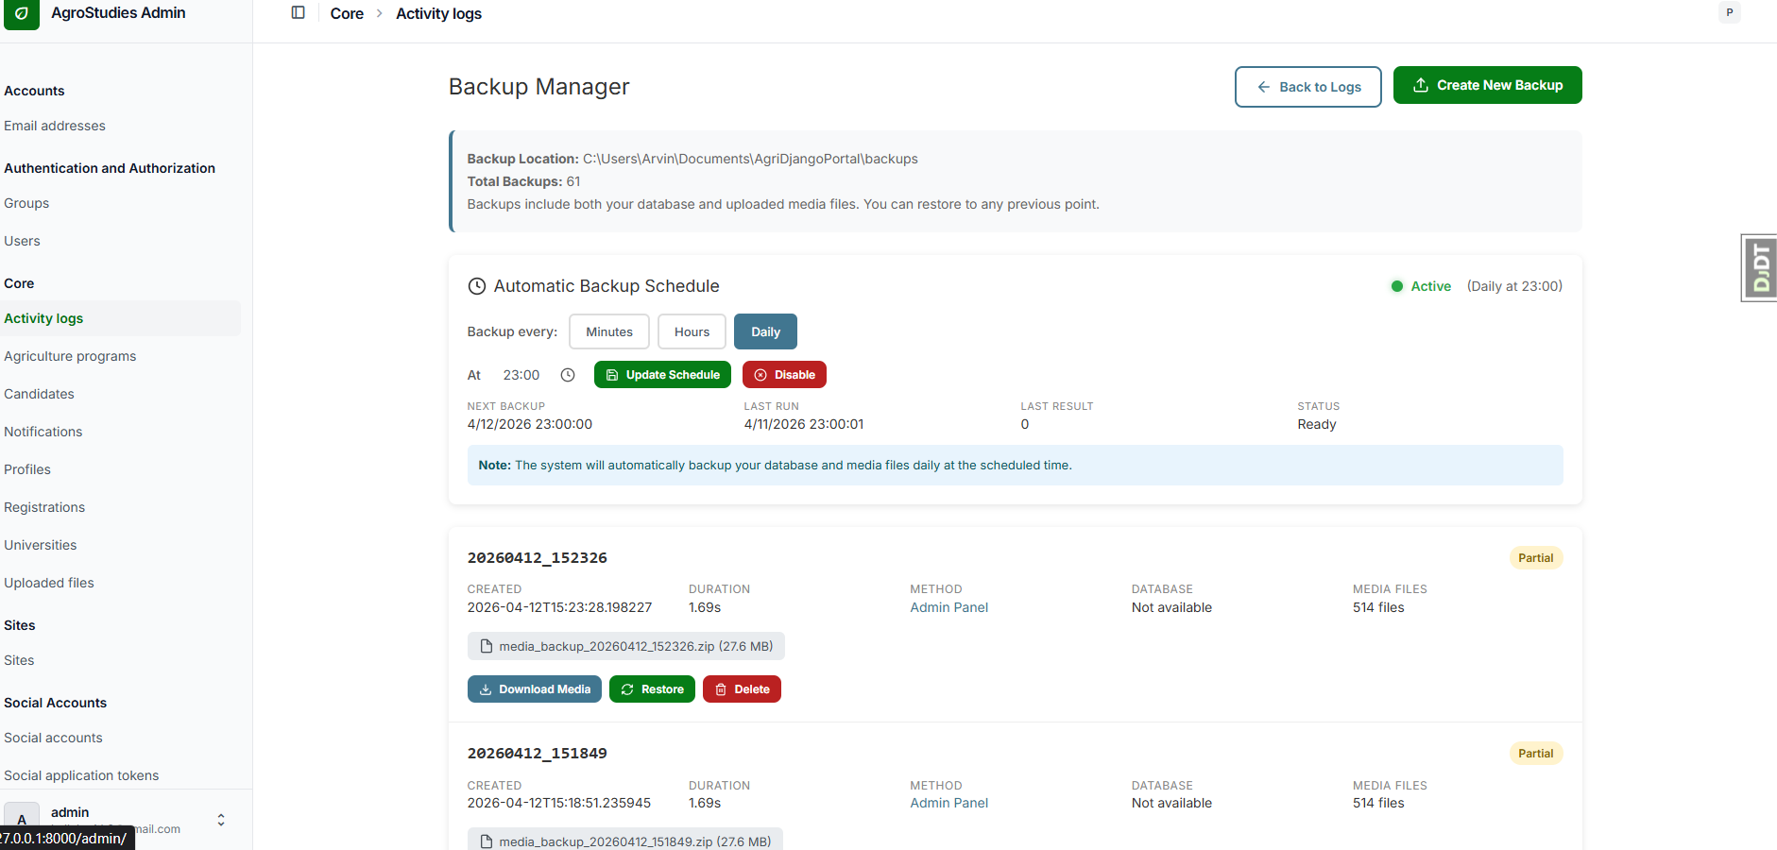
Figure 8. System Backup Management Interface

Figure 8 shows the system backup management interface, which enables administrators to configure and monitor automated data backup processes. This module is essential for ensuring data reliability and system continuity, as it allows for regular preservation of critical system information. In the event of system failure, data corruption, or security incidents, the backup system facilitates efficient recovery of stored data. By implementing this feature, the system enhances its resilience and ensures the protection of sensitive user and application data.

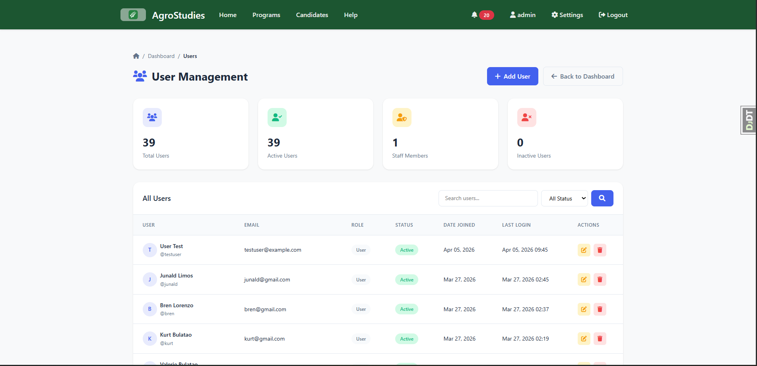

Figure 9. User Account Management Interface

Figure 9 presents the user account management interface, where administrators can create, update, and manage user accounts within the system. This module allows for the assignment of roles and permissions, ensuring that access to system functionalities is controlled and restricted based on user responsibilities. It supports the implementation of role-based access control, which is essential for maintaining system security and operational integrity. Additionally, the interface provides administrators with the ability to monitor and manage user activity, contributing to better system governance.

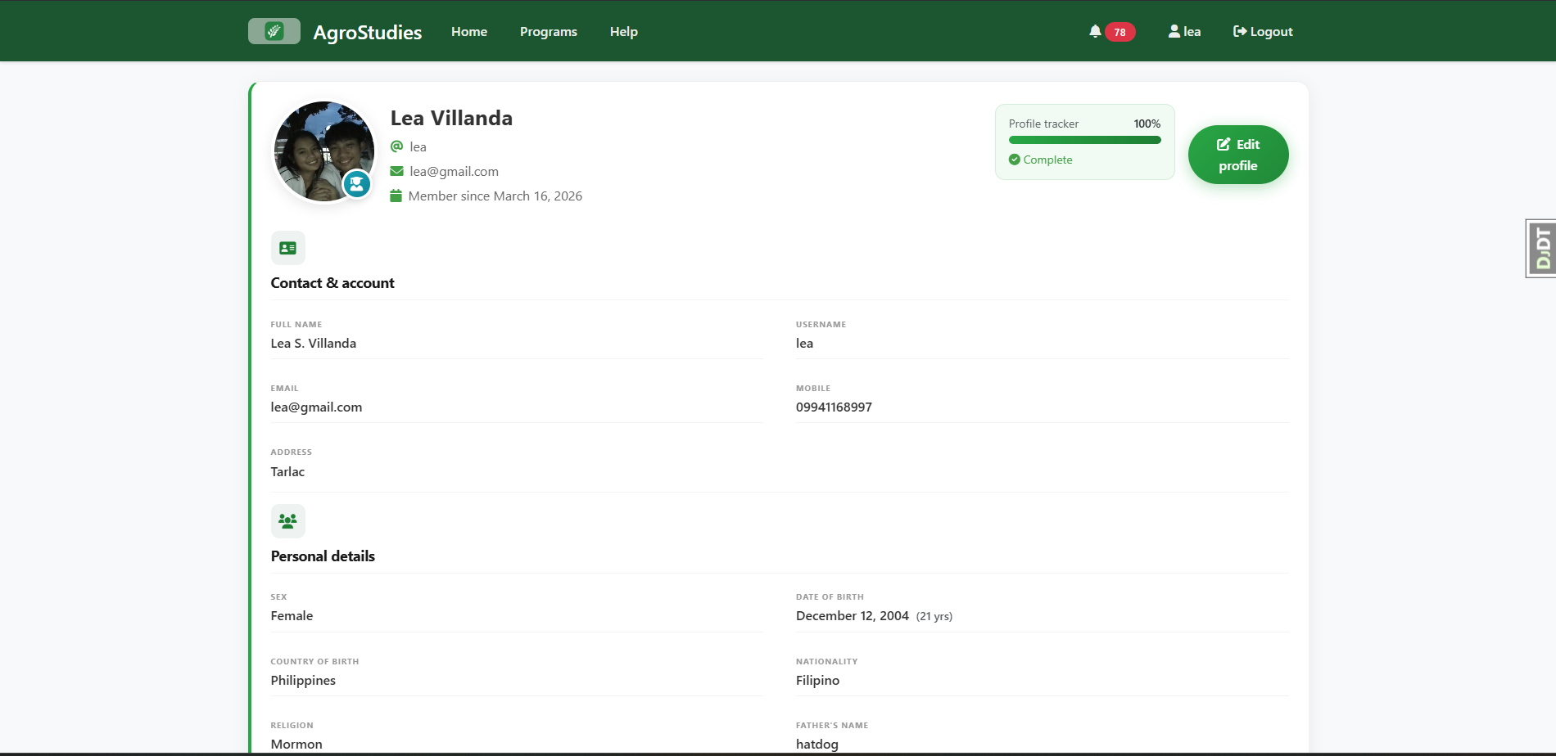
Figure 10. Candidate Profile Information Interface

Figure 10 shows the candidate profile interface, which displays detailed information about individual applicants. This includes personal details, academic background, uploaded documents, and current application status. The interface is designed to support efficient verification and evaluation of applicant data by providing a comprehensive and organized view of relevant information. This functionality enables administrators to make accurate and informed decisions during the selection and approval process, while also ensuring that all required data is readily accessible.

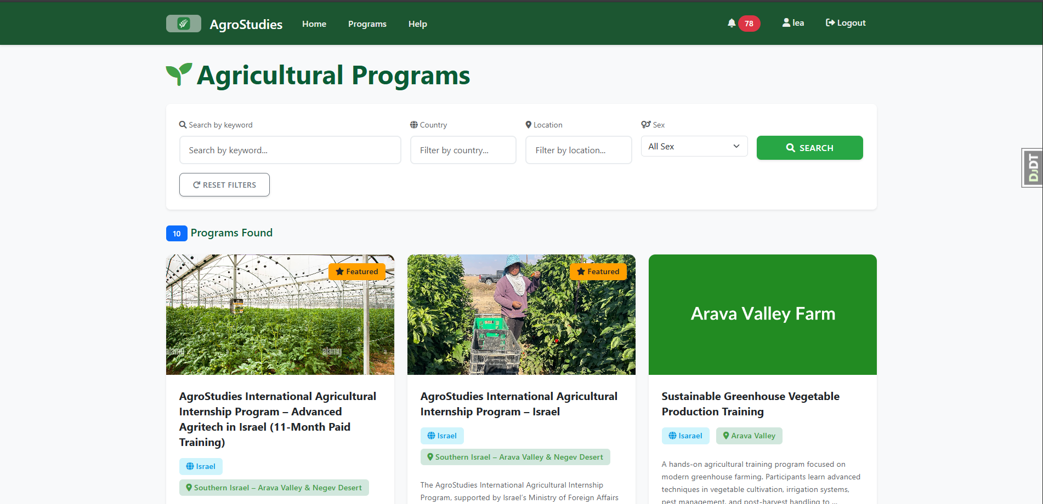
Figure 11. List of Program Applications Interface

Figure 11 illustrates the program applications list interface, where administrators can view and manage all submitted internship applications. The module provides a structured overview of applications, including their current status and associated applicant details. It allows administrators to perform essential actions such as reviewing, approving, or rejecting applications. This interface enhances transparency and accountability in the application process by enabling real-time tracking and efficient monitoring of application progress.

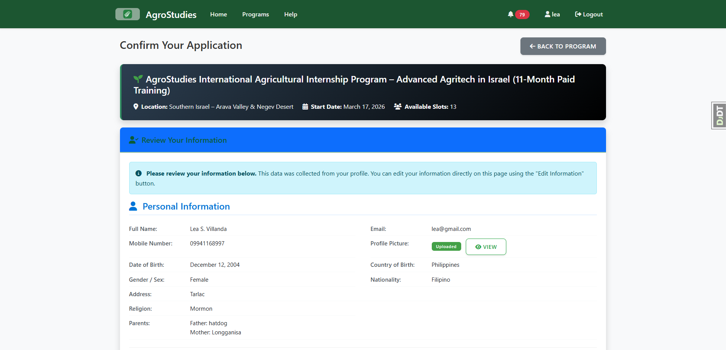
Figure 12. Internship Application Submission Form

Figure 12 presents the internship application submission form used by candidates to apply for available programs. The interface is designed to collect essential information, including personal details, required documents, and preferred farm selections. It ensures a standardized and structured approach to application submission, minimizing errors and incomplete entries. Additionally, the form supports validation mechanisms to ensure data accuracy and completeness. This module plays a vital role in streamlining the application process and improving the overall user experience for applicants.

Flowchart

Hardware and Software Requirements
Hardware. The following are the minimum hardware requirements to run and operate the system.
Table 4. Hardware Requirements
CLASIFICATION | Specification
OS | Windows 7, 10 and 11
Processor | Intel Core i5-1235U 1.30 GHz or  Ryzen 5 5500U 2.10GHz
RAM | 4.00 GB RAM
Storage | 128 GB SSD STORAGE
Mobile Phone | Android 8 and above
 | IOS

Table 4 shows that the TAU Agrostudies Portal can operate on commonly available computing devices. The system requires at least an Intel Core i5-1235U or AMD Ryzen 5 5500U processor, 4 GB of RAM, and 128 GB SSD storage to ensure responsive performance. It also supports mobile access through Android 8 and above and iOS devices, allowing users to conveniently access the portal using smartphones and tablets. These requirements demonstrate that the system is designed to be accessible without requiring high-end hardware, making it suitable for a wide range of users.

Software. The following are the minimum software requirements to run and operate the system.
Table 5. Software Requirements
Component | Specification
Browser | Chrome
 | Microsoft Edge
 | Firefox
 | Safari
 | Brave

Table 5 shows that the TAU Agrostudies Portal is browser-based and can be accessed using widely used web browsers, including Google Chrome, Microsoft Edge, Mozilla Firefox, Safari, and Brave. By supporting multiple browsers, the system provides flexibility and convenience for users while ensuring compatibility across different platforms and devices. This approach eliminates the need for specialized software installation, allowing users to access the portal through standard internet browsers.

End-User Evaluation Results
Evaluation or Validation Results presents the result of the user evaluation or any testing process used with software tools to validated the IT Solution based on the metrics in the specific objectives.
Introduce the table first. Refer to it as labeled. The format of this section may be as the following example. Table 4 presents the result of evaluation for the Software Usability.
Table 6. Evaluation of Users on Software Usability.
1. USABILITY | Average | Descriptive rating
A.1 The system is easy to use even for first-time users. | 4.83 | Excellent
A.2 The layout of the system is clear and visually organized. | 4.83 | Excellent
A.3 The instructions and steps in the application process are easy to follow. | 4.75 | Excellent
A.4 The navigation between pages is smooth and user-friendly. | 4.70 | Excellent
A.5 The system loads quickly and responds efficiently. | 4.69 | Excellent
Section Mean | 4.76 | Excellent
Table 6 presents the evaluation of users on software usability, with a section mean of 4.76, Excellent. The results indicate a consistently strong perception of usability across all aspects of the system. The values are closely grouped, which suggests that users experienced a uniform level of ease when interacting with different parts of the interface. This pattern shows that usability was not limited to a single feature but was integrated throughout the system design.

Table 7. Evaluation of User on Software Functionality.
B. FUNCTIONALITY | Average | Descriptive rating
B.1 The system allows easy submission of internship applications. | 4.83 | Excellent
B.2 The system properly uploads and stores all required documents. | 4.79 | Excellent
B.3 The application tracking feature provides accurate and real-time updates. | 4.79 | Excellent
B.4 The farm selection feature works correctly after application approval | 4.85 | Excellent
B.5 The system supports all necessary tasks for internship application. | 4.80 | Excellent
Section Mean | 4.81 | Excellent

Table 7 shows the evaluation of users on software functionality, with a section mean of 4.81, Excellent. The results reflect a very high level of system performance in executing its intended tasks. The consistently high scores across all indicators suggest that users were able to complete key processes without encountering functional issues. This indicates that the system’s core features are reliable and aligned with user needs.

Table 8. Evaluation of Users on Software Reliability.
C. RELIABILITY | Average | Descriptive rating
C.1 The system works without frequent errors during use. | 4.84 | Excellent
C.2 The system ensures that submitted applications and documents are not lost. | 4.82 | Excellent
C.3 The system is available whenever it is needed by users. | 4.78 | Excellent
C.4 The system provides consistent updates on application status. | 4.85 | Excellent
C.5 The system performs reliably throughout the entire process. | 4.76 | Excellent
Section Mean | 4.81 | Excellent

Table 8 presents the evaluation of the system in terms of functionality, with a section mean of 4.81, Excellent. The slightly higher mean compared to usability suggests that users perceived the system’s core features as highly effective in accomplishing intended tasks. The consistency of high ratings indicates that essential operations, such as submission, tracking, and processing, were executed reliably without noticeable issues. This pattern reflects that the system is not just user-friendly but also capable of delivering its primary purpose efficiently. The trend highlights that functionality was a strong point of the system, meaning users were able to complete tasks with confidence in the system’s performance.
Table 9. Accuracy of the IT Solution.
dataset | score
Training Dataset (60%)
Model Test Dataset (40%)

Table 10. Evaluation of Admin on Software Usability.
1. USABILITY | Average | Descriptive rating
1.1 The administrator dashboard is easy to understand and interpret. | 4.00 | Very Good
1.2 The navigation between system modules is clear and intuitive. | 4.00 | Very Good
1.3 The layout and design help administrator complete tasks efficiently. | 4.00 | Very Good
1.4 The system provides clear labels, instructions, and interface elements. | 4.00 | Very Good
1.5 The system is easy to learn even without extensive training. | 3.00 | Good
Section Mean | 3.8 | Good
Table 10 presents the evaluation of administrators on software usability. The results indicate that the system provides a generally organized and manageable user experience for administrative tasks. The ratings suggest that administrators were able to navigate the system and understand its interface without major difficulty, reflecting that the layout and module arrangement support efficient workflow management. The close grouping of most responses also implies consistency in how administrators perceived the usability of the platform.

Table 11. Evaluation of Admin on Software Functionality.
1. USABILITY | Average | Descriptive rating
1.1 The system effectively manages applicant records and data in an organized manner. | 5.00 | Excellent
1.2 The document verification and approval process functions correctly without errors. | 4.00 | Very Good
1.3 The system generates accurate and complete reports needed by administrators. | 5.00 | Excellent
1.4 The filtering and sorting features help administrators efficiently process applicants. | 5.00 | Excellent
1.5 The system supports all administrative tasks required in managing internships. | 5.00 | Excellent
Section Mean | 4.8 | Excellent

Table 11 presents the evaluation of administrators on software functionality. The results demonstrate that the system effectively supports the operational requirements involved in managing internship applications and related administrative processes. The consistently high evaluations across most indicators suggest that the core features of the system performed according to expectations and were able to assist administrators in handling records, reports, and applicant processing efficiently.

Table 12. Evaluation of Admin on Software Reliability.
1. USABILITY | Average | Descriptive rating
1.1 The system operates without crashes during usage. | 5.00 | Excellent
1.2 The system ensures that all data are securely stored and not lost. | 5.00 | Excellent
1.3 The system performs well even when handling multiple users or applicants. | 5.00 | Excellent
1.4 The backup and recovery features function properly when needed. | 5.00 | Excellent
1.5 The system consistently performs its intended operations without failure. | 5.00 | Excellent
Section Mean | 5.00 | Excellent

Table 12 presents the evaluation of administrators on software reliability. The results reveal a very strong level of confidence in the stability and dependability of the system during operation. The uniformity of the ratings indicates that administrators consistently experienced smooth system performance across different processes and functionalities. This pattern suggests that the platform was able to maintain stable operations even when handling important administrative activities and data management tasks.

Table 13. Accuracy of the IT Solution.
dataset | score
Training Dataset (60%)
Model Test Dataset (40%)

Table 14. Evaluation of IT Expert on Software Usability.
1. USABILITY | Average | Descriptive rating
1.1 The system follows standard user interface and user experience design principles. | 4.4 | Excellent
1.2 The interface is consistent, well-organized, and easy to understand. | 4.8 | Excellent
1.3 The system provides clear and helpful error messages and validations. | 4.6 | Excellent
1.4 The system is responsive and works well across different devices. | 4.2 | Excellent
1.5 The workflow of the system is logical and efficient. | 4.6 | Excellent
Section Mean | 4.52 | Excellent

The usability results indicate that the system provides a generally smooth and accessible user experience, as reflected by its high overall average of 4.52. This suggests that users are able to navigate and interact with the system with minimal difficulty. The consistency of the ratings implies that design elements such as layout, responsiveness, and workflow are working together effectively rather than independently. What the numbers point to is a system that already meets standard user expectations, particularly in terms of clarity and organization. However, compared to the other criteria, usability shows slightly more variation. This signals that while the interface is strong, there may still be small areas where user interaction could be refined further, such as improving intuitiveness or reducing minor friction in navigation. Overall, the results suggest that the system is user-friendly and accessible, supporting efficient task completion without requiring extensive user training.

Table 14. Evaluation of IT Expert on Software Functionality.
1. FUNCTIONALITY | Average | Descriptive rating
1.1 The system meets all defined functional requirements specified in the study. | 5.00 | Excellent
1.2 All system modules function correctly according to their design. | 4.8 | Excellent
1.3 The system processes inputs and outputs accurately and efficiently. | 5.00 | Excellent
1.4 The Role-Based Access Control (RBAC) is properly implemented and enforced. | 5.00 | Excellent
1.5 The system security features such as authentication and validation are effective. | 4.4 | Excellent
Section Mean | 4.84 | Excellent

The functionality evaluation achieved the highest overall average of 4.84, indicating that the system performs its intended tasks with a high degree of accuracy and completeness. This reflects strong alignment between the system’s design and its actual implementation. The pattern of scores shows that the system’s core operations are not only present but are executed reliably and consistently. This implies that users can depend on the system to produce correct outputs and handle processes as expected. The strong performance in this area also highlights that key features, including system processes and access control mechanisms, are effectively integrated. From an analytical perspective, this suggests that the system’s foundation is solid. The high functionality rating confirms that the project successfully meets its primary objectives, making it dependable for real-world use.

Table 15. Evaluation of IT Expert on Software Reliability.
1. REliability | Average | Descriptive rating
1.1 The system demonstrates high availability and minimal downtime. | 4.6 | Excellent
1.2 The system handles errors and exceptions properly without crashing. | 4.8 | Excellent
1.3 The system maintains consistent performance under different conditions. | 4.8 | Excellent
1.4 The system has been properly tested through unit testing procedures. | 4.4 | Excellent
1.5 The system is secure against common vulnerabilities such as SQL injection and XSS. | 4.8 | Excellent
Section Mean | 4.68 | Excellent

The reliability results, with an overall average of 4.68, demonstrate that the system maintains stable performance under varying conditions. The scores reflect a system that is capable of operating continuously with minimal issues, which is essential for user trust and long-term usability. The data suggests that the system handles unexpected situations effectively, maintaining performance without significant failure. The relatively strong ratings across indicators point to good system stability, proper error handling, and adequate security measures. This means the system is not only functional but also dependable in actual usage scenarios. While slightly lower than functionality, the reliability scores remain consistently high, indicating that any limitations are minor and do not significantly affect system performance. This reinforces the idea that the system is robust and capable of sustaining regular operations.

Insert screenshots of tools or parts of the system that shows what were evaluated on the parameters measured (example Security = Log-In Interface). Introduce figures first and reference them using their caption. For Model Testing, a graph or chart can be inserted for interpretation.
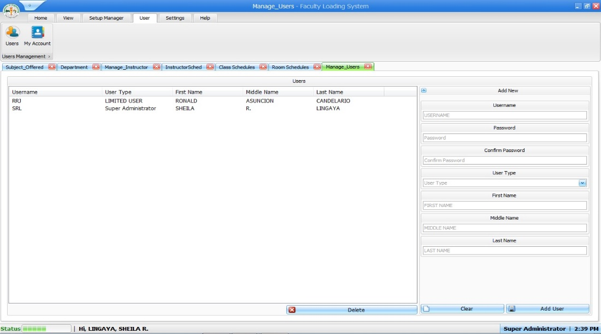

Figure 2. Screenshot Showing Evaluated Feature

For example, Figure 2 shows the Add User Interface where the user adds data to complete the transaction in adding of user for Administrator and Super Administrator. Administrator Account and Super Administrator account has the same privilege in using the system while the limited user can only add schedule.

Unit Testing Result
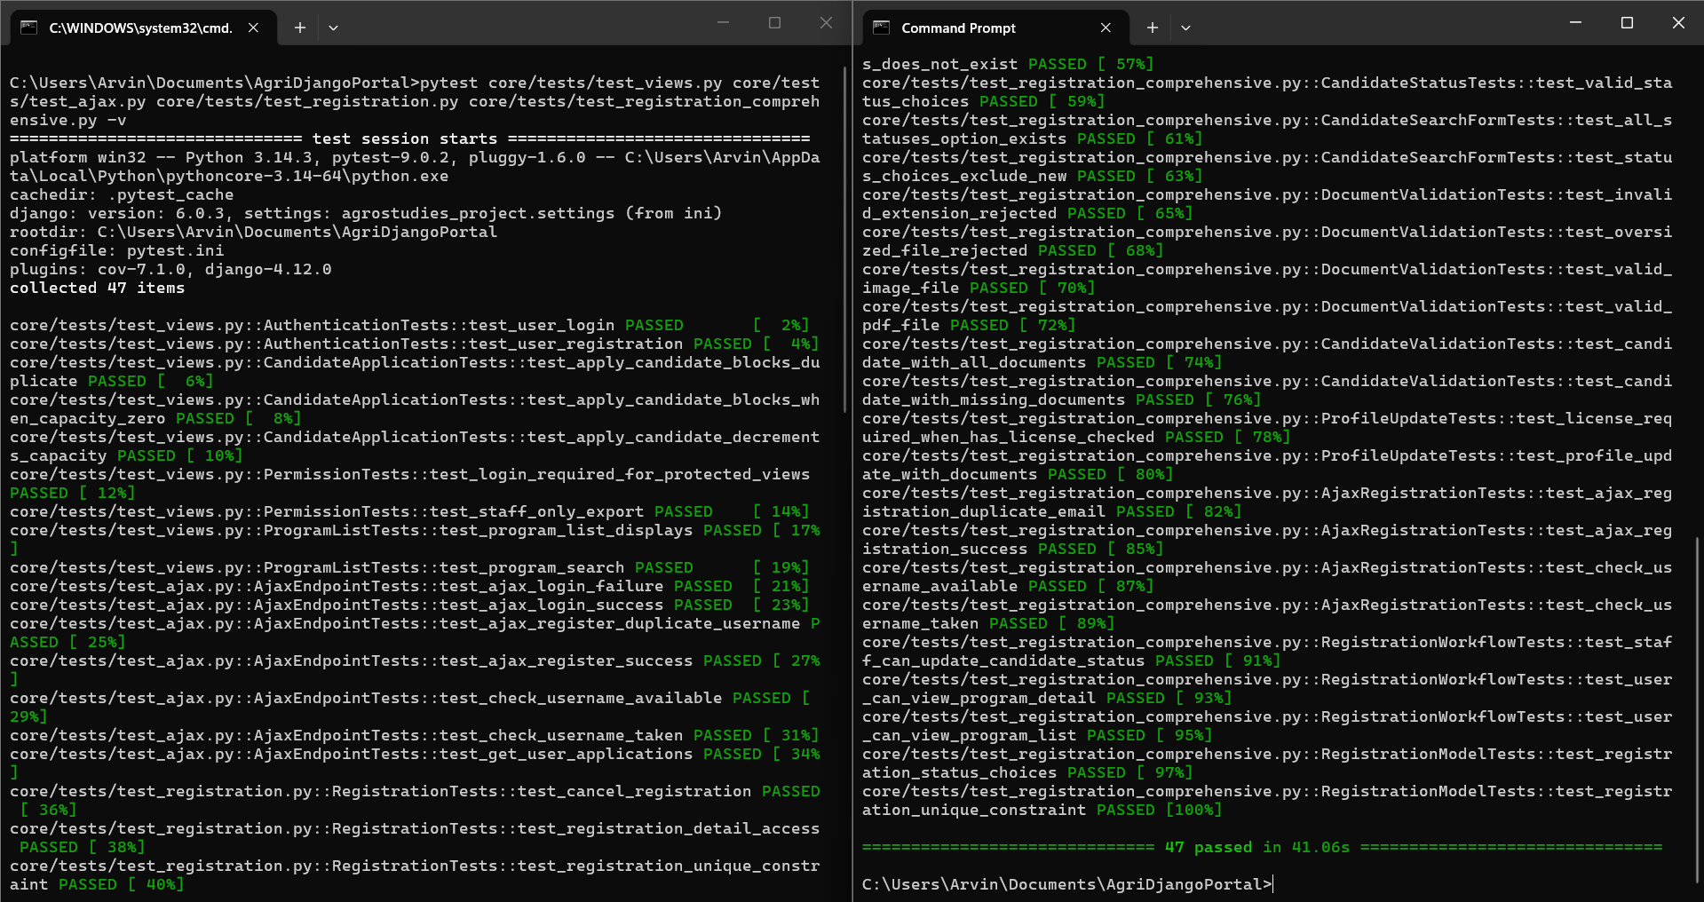
Figure 13. Candidate Module Unit Testing Interface

Figure 13 presents the unit testing results for the candidate module of the TAU Agrostudies Portal. This module was tested to verify the correctness and reliability of functionalities related to applicant registration, profile management, application submission, and status tracking. The testing process involved executing predefined test cases to validate input handling, data processing, and system responses under various scenarios. The results demonstrate that the module functions as intended, producing accurate outputs and handling user inputs effectively. This confirms that the candidate-related features are stable and ready for integration within the overall system.

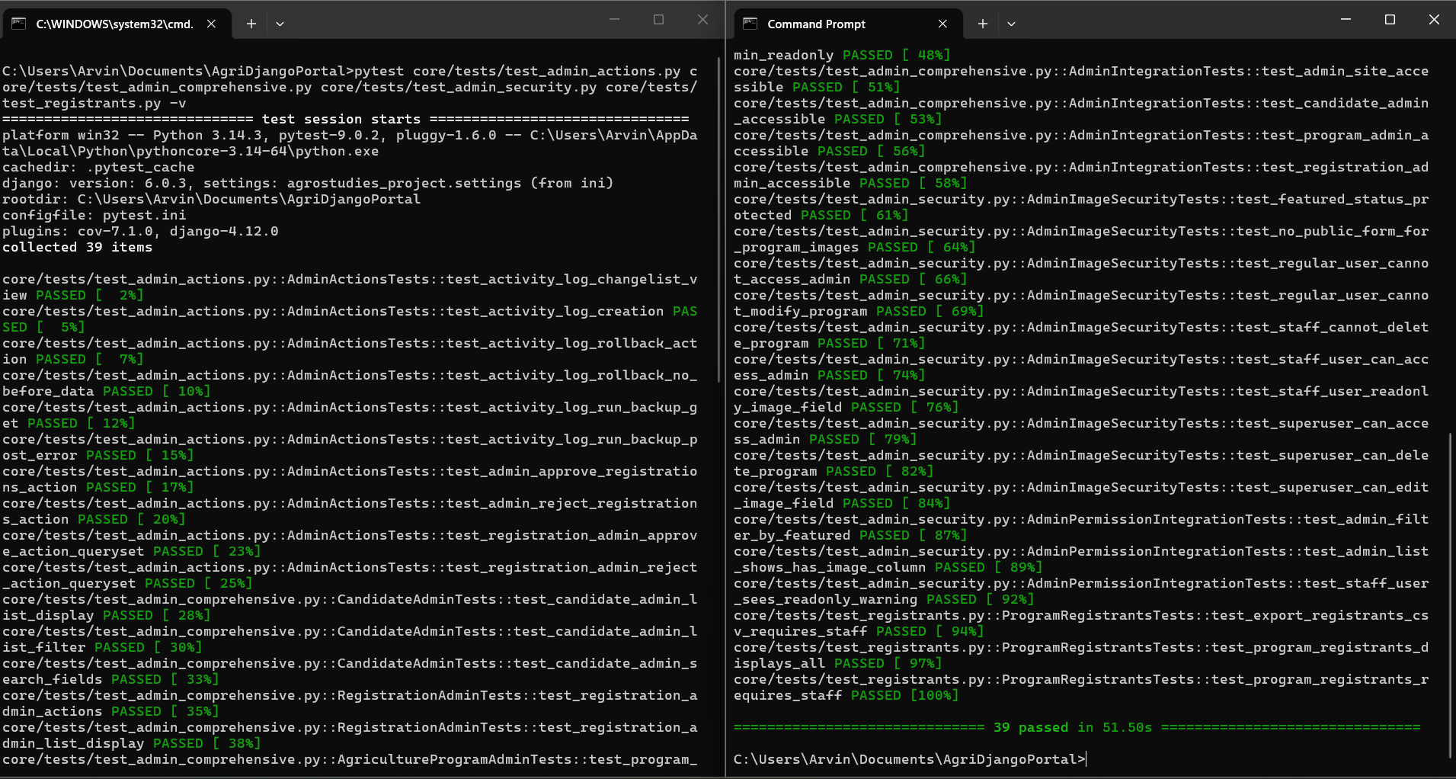
Figure 14. Administrator Module Unit Testing Interface

Figure 14 illustrates the unit testing performed on the administrator module, which is responsible for managing system operations and overseeing applicant data. The testing focused on critical functionalities such as candidate management, document verification, application approval or rejection, and report generation. Each component was tested independently to ensure proper execution of administrative tasks and adherence to system requirements. The results indicate that the module performs reliably, with correct processing of administrative actions and appropriate system responses. This validates the effectiveness of the administrator functionalities in supporting efficient system management.

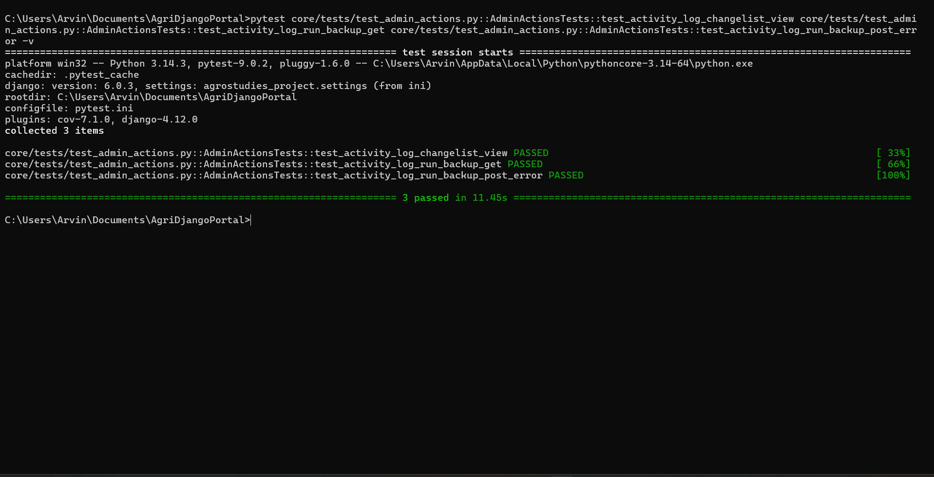
Figure 15. Automated Backup Module Unit Testing Interface

Figure 15 shows the unit testing results for the automated backup module of the system. This module was evaluated to ensure that data backup processes are executed correctly and consistently without errors. The testing included scenarios such as scheduled backups, data storage validation, and recovery readiness. Results confirm that the backup system successfully preserves system data and maintains integrity during storage operations. This functionality is critical in ensuring system reliability, as it provides protection against data loss and supports recovery in case of system failure or unexpected disruptions.

SUMMARY, CONCLUSION AND RECOMMENDATION

Summary
The study focused on the development of the TAU Agrostudies Portal for Managing International Agricultural Internships at Tarlac Agricultural University. The primary objective of the study was to create a centralized web-based system that would improve the management of internship applications, document submission, applicant monitoring, and internship deployment processes. The researchers aimed to address the limitations of the existing manual procedures, which often resulted in delays, inefficient record handling, and difficulties in monitoring applicants and internship programs.
The researchers utilized the Agile Development Methodology in developing the system. This methodology allowed continuous improvement and refinement of the portal through iterative development, testing, and feedback gathering. The system was developed using Django as the backend framework, along with HTML, CSS, JavaScript, Tailwind CSS, and Bootstrap for the frontend interface. PostgreSQL was used as the production database to support scalability and efficient data management.
Data gathering procedures included interviews, questionnaires, and document sampling. Interviews with faculty members and advisers helped identify the required system functionalities, while questionnaires gathered feedback regarding usability, efficiency, and expected features of the portal. Existing internship documents and records were also analyzed to determine the appropriate database structure and document requirements.
The developed system included several major functionalities such as user authentication, applicant profile management, document uploading and verification, internship application submission, candidate management, internship program management, report generation, and notification management. Security mechanisms including Role-Based Access Control (RBAC), encrypted data transmission through HTTPS, password hashing, CAPTCHA, and regular backups were implemented to ensure the safety and integrity of user data.
The system underwent unit testing and Vulnerability Assessment and Penetration Testing (VAPT) to verify reliability, functionality, and security. Results showed that the system operated properly and was resilient against common web-based threats.
The evaluation results demonstrated that the system achieved high levels of acceptability among respondents. End users evaluated the system with excellent ratings in software usability, functionality, and reliability, obtaining section means of 4.76, 4.81, and 4.81 respectively. Administrators also rated the system positively, particularly in functionality and reliability, with section means of 4.8 and 5.00. IT experts further assessed the system and found that the portal met standard usability, functionality, and security requirements. These findings indicate that the TAU Agrostudies Portal effectively supports internship management processes and improves operational efficiency.

Conclusion
- The TAU Agrostudies Portal for Managing International Agricultural Internships was successfully developed as a centralized web-based system that addressed the existing limitations of manual internship application and deployment processes at Tarlac Agricultural University. The system was developed using the Agile Development Methodology, which enabled continuous improvement, testing, and refinement throughout the development cycle. The portal was built using Django as the backend framework together with HTML, CSS, JavaScript, Tailwind CSS, and Bootstrap for the frontend interface. SQLite3 was utilized during the development stage, while PostgreSQL was implemented for deployment to support scalability and efficient database management. The system also utilized Git and GitHub for version control and collaboration, while Visual Studio Code served as the development environment.
- The developed system successfully integrated major functionalities necessary for managing international agricultural internships. These functionalities include user registration and authentication, applicant profile management, document uploading and verification, internship application submission, candidate filtering and sorting, internship program management, report generation, notification management, and backup management. The portal also implemented security mechanisms such as Role-Based Access Control (RBAC), HTTPS encryption, bcrypt password hashing, CAPTCHA protection, and activity logging to ensure the security, confidentiality, and integrity of user data and system operations.
- The unit testing and Vulnerability Assessment and Penetration Testing (VAPT) conducted on the system confirmed that the TAU Agrostudies Portal performs reliably and securely. The testing procedures demonstrated that the system was capable of handling core operations accurately and consistently while resisting common web-based security threats such as SQL injection, cross-site scripting (XSS), cross-site request forgery (CSRF), and unauthorized access attempts. These results indicate that the system provides a stable and dependable platform for both administrators and student applicants.
- The evaluation results revealed that the developed system is highly acceptable in terms of software usability, functionality, and reliability. End users evaluated the system with Excellent ratings, obtaining section means of 4.76 for usability, 4.81 for functionality, and 4.81 for reliability. These findings indicate that users found the system easy to use, responsive, organized, and capable of supporting the required internship application processes efficiently.
- The administrators also positively evaluated the system, particularly in terms of functionality and reliability. The system received a section mean of 4.80 for functionality and 5.00 for reliability, indicating that the portal effectively supports administrative operations such as applicant management, document verification, report generation, filtering, and internship monitoring. The results further suggest that the system consistently performed its intended tasks without operational failures or data management issues.
- The evaluation conducted by IT experts confirmed that the TAU Agrostudies Portal complies with standard principles of usability, functionality, responsiveness, and system security. The experts recognized that the system provides an organized interface, efficient workflow, accurate processing of data, and proper implementation of security controls such as authentication and role-based access management. These findings demonstrate that the developed portal meets the technical and operational requirements expected from a modern web-based internship management system.
- Overall, the study concludes that the TAU Agrostudies Portal is an effective and reliable solution for improving the management of international agricultural internship programs at Tarlac Agricultural University. The developed system enhances efficiency, minimizes manual processing, improves accessibility of records and applications, strengthens security, and supports better coordination between students, administrators, and internship partners..

Recommendation
The researchers propose the following enhancements and recommendations for the Development of the TAU Agrostudies Portal for Managing International Agricultural Internship, addressing potential limitations for future development:
- The university may officially adopt and implement the TAU Agrostudies Portal to improve the efficiency and organization of internship management processes.
- Future researchers may enhance the system by integrating advanced technologies such as artificial intelligence for applicant matching, predictive analytics, and automated recommendation systems.
- Mobile application support may be developed to provide users with more accessible and convenient access to the portal through smartphones and tablets.
- Additional communication features such as real-time chat, email notifications, and SMS integration may be included to strengthen coordination among students, administrators, and partner institutions.
- Future developers may integrate cloud-based storage solutions and scalable infrastructure to support larger volumes of users and internship records.
- The system may also include advanced analytics and reporting dashboards to assist administrators in monitoring internship trends, student performance, and deployment statistics more effectively.
- Continuous security testing and system maintenance should be conducted to ensure protection against emerging cybersecurity threats and vulnerabilities.
- Further studies may evaluate the long-term effectiveness and user satisfaction of the system after full implementation within the university.

REFERENCES

Use APA 7th Citation Style formatting for all references (in the body and in the listing here). Insert using Mendeley.

APPENDICES

Appendix A. User Interfaces

Place your appendices here. Please be sure that these have been referenced in the body of document.

Appendix B. Sample Generated Reports

Appendix C. Evaluators' Questionnaire

Appendix D. Evaluators' Profile

Appendix E. Grammarian's Certificate

____________________
Date
GRAMMARIAN’S CERTIFICATE
This is to certify that the undersigned has reviewed and went through all the pages of the manuscript of the project / research project entitled “COMPUTERIZED FACULTY LOADING SYSTEM FOR THE INSTITUTE OF ENGINEERING” as against the set of structural rules that govern the composition of sentences, phrases and words in the English language and the Information Technology technical writing.

Signed:

FIRSTNAME MI. LASTNAME
Position
Affiliation

Appendix F. TAU-DRD-QF-43-Recommendation of Panel Members Form
Appendix G. TAU-CET-QF-01 Proposed Titles for Approval of Committee
Appendix H. TAU-DRD-QF-44-Thesis Title Approval Form

Appendix I. TAU-DRD-QF-45-Thesis Outline Approval Form
Appendix J. TAU-DRD-QF-34 Ethics Checklist
Appendix K. TAU-DRD-QF-47 Request for Oral Examination (Outline)

Appendix L. TAU-CET-QF-05 Evaluation Form for Outline Presentation

Appendix M. TAU-DRD-QF-35 Endorsement of Research Ethics

Appendix N. TAU-DRD-QF-47-Request for Oral Examination (Final Defense)
Appendix O. TAU-CET-QF-05-Evaluation Form for Outline/Oral Presentation (Final Defense)
Appendix P. TAU-CET-QF-10-Approval for Final Circulating Copy
Appendix Q. TAU-DRD-QF-39-Test for Similarity Index
Appendix R. TAU-DRD-QF-40-Similarity Index Certificate

